January 2016

Spring Important Dates
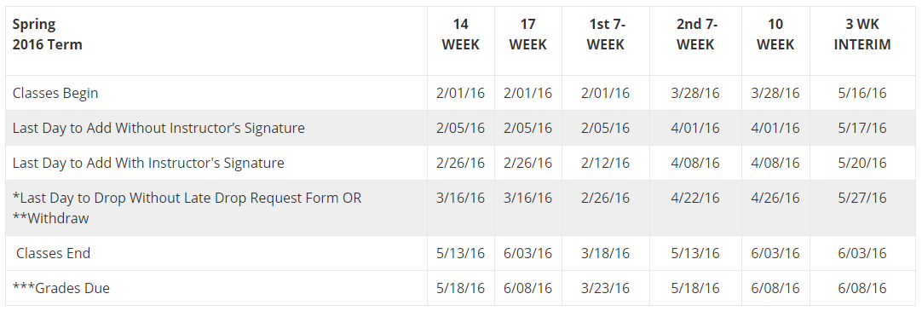
Other Important Spring Dates

March 20-27: Spring Break
May 14: Commencement Ceremony
May 30: Memorial Day, Legal Holiday (no interim classes)
June 3: Official Graduation Date

Summer Important Dates

February 22: Registration begins for degree-seeking undergraduate students. They should check Titan Web for their specific day and time.
February 29: Registration begins for undergraduate special (non-degree) students.

Advisory Council for Comprehensive Academic Advising (ACCAA)
The Advisory Council for Comprehensive Academic Advising (ACCAA) was formed in Spring 2003 and consists of students, faculty and staff. www.uwosh.edu/accaa
The Council's first goal was to educate itself with the Consultant's report and other advising study reports in order to structure recommendations appropriate for the advising system at the University of Wisconsin Oshkosh. The mission of ACCAA is
to provide guidance and support to the Director of Academic Advising and to provide the University community information and guidance around issues of academic advising.
ACCAA has succeeded in creating a campus definition of academic advising, formally outlined academic advising roles and responsibilities and coordinates the faculty advisor award process on a yearly basis. For more information about ACCAA, please visit: www.uwosh.edu/accaa

ACCAA Advising Outcomes
In 2014, the ACCAA proposed and the campus approved, the following outcomes of advising:
Outcome 1:
Students are able to locate and use academic information and campus resources.
Outcome 2:
Students are able to understand and describe graduation requirements.
Outcome 3:
Students are able to select and plan an academic program based on research, interests, skills, values and career goals.

The Student At Risk Response Team (SARRT)
Faculty and staff are often the first to recognize that a student may not be doing well academically and/or emotionally. Students have a better chance at succeeding in their college career when a peer, parent, faculty or staff member link them to help on campus. Reaching out to students not only helps them personally but enhances their academic success as well.

The Student At Risk Response Team (SARRT) is a central network focused on prevention and early intervention with students who are experiencing extreme distress or engaging in harmful or disruptive behaviors. Contact the Counseling Center (920) 424-2061 or the Dean of Students Office (920) 424-3100 to consult about a student of concern.

SARRT gathers information, develops strategies to assist with potentially harmful or disruptive behavior and coordinates support resources to help students maintain satisfactory academic progress, promote their health and well-being and enhance campus safety.

The following offices meet weekly for team discussions: Counseling Center, Dean of Students Office of the Provost, Student Health Center, Residence Life, University Police and Student Affairs. Others are included on a case by case basis.

Typical consultations involve students with aggressive/disruptive behavior or mental health problems such as: suicide risk, eating disorders, and alcohol and drug problems.

Some distress signals include:
- Depression: poor concentration, loss of interest, withdrawal
- Agitation: anxious, cannot sit still
- Disorientation: seems “out of it”, may exhibit bizarre behavior
- Suicidal expression: thoughts or threats
- Alcohol or drug abuse: including coming to class intoxicated

You may also notice:
- Increased irritability, undue aggressive or abrasive behavior
- Excessive procrastination, poor class attendance, little or no work completed
- Marked change in personal hygiene
- Dependency (e.g., the student who hangs around or makes excessive appointments to see you)
- Alarming or dangerous behaviors
Campus Resources
Social/Peer/Personal Concerns
- Counseling Center http://www.uwosh.edu/couns_center/
- Dean of Students Office http://www.uwosh.edu/deanofstudents/
- LGBTQ Center http://www.uwosh.edu/lgbtqcenter
- Residence Life (roommate issues, security concerns) http://www.housing.uwosh.edu/
- Student Leadership and Involvement Center SLIC http://reeve.uwosh.edu/involvement
- Student Recreation and Wellness Center SWRC http://recreation.uwosh.edu/
- Titan Volunteer http://reeve.uwosh.edu/involvement/volunteerism
- University Police (assault, hate crimes, stalking, and security concerns) http://www.uwosh.edu/up/
- Veterans Resource Center VRC (adapting to Civilian Life) http://www.uwosh.edu/veterans
- Women’s Center http://www.uwosh.edu/womenscenter/
Academic Concerns
- Center for Academic Resources CAR (tutoring) http://www.uwosh.edu/car/
- Dean of Students http://www.uwosh.edu/deanofstudents/
- Financial Aid (Concerned about paying for school and living expenses) http://www.uwosh.edu/fin_aid/
- Math Lab http://www.uwosh.edu/mathematics/resources/tutor-labs
- Project Success http://www.uwosh.edu/success/
- Reading and Study Skills Center http://www.uwosh.edu/readingstudycenter/
- Undergraduate Advising Resource Center UARC (Advising) http://www.uwosh.edu/advising/
- Veterans Resource Center - VRC (GI Bill, adjusting to the not as structured learning environment) http://www.uwosh.edu/veterans
- Writing Center http://www.uwosh.edu/wcenter/
Career/Professional
- Alumni Mentors http://www.uwosh.edu/alumni
- Career Services http://www.uwosh.edu/career/
- Counseling Center http://www.uwosh.edu/couns_center/
- Faculty Members
- Undergraduate Advising Resource Center UARC (Advising) http://www.uwosh.edu/advising/

Advising Outcomes

