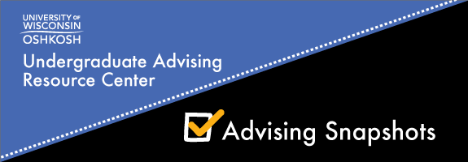
March 2016

The Value of Faculty Advising
Faculty advisors are an important and critical aspect to the development of a student’s educational and career plan. Faculty advisors help students develop an extensive knowledge within their programs, ignite enthusiasm for a discipline and establish a link between students and the university. (Kennemer and Hunt, 2013)

Resource article
Kennemer, C. & Hurt, B. (2013). Faculty advising. Retrieved from the NACADA Clearinghouse of Academic Advising Resources Web site http://www.nacada.ksu.edu/Resources/Clearinghouse/View-Articles/Faculty-advising.aspx

Faculty Advisor Award
The UW Oshkosh Advisory Council for Comprehensive Academic Advising (ACCAA) selects two faculty/instructional academic staff advisor for the faculty advisor award; one award is given each semester.
Recipients of this award receive a $100 Oshkosh Chamber of Commerce gift certificate. In addition, winners are eligible to be nominated for the Wisconsin Academic Advising Association Faculty Advisor Award.
Nominations are submitted by students. The criteria include availability to students; academic and career planning assistance; referrals to resources; participate in advising development activities as provided by the UARC and communication.

Below are quotes from Fall 2015 Faculty Advisor Award Nominee submissions:

Tim Gleason, Journalism
“He was relatable, approachable, and shockingly positive – which was just what I needed when I transferred back to UW Oshkosh, someone on my side and someone to tell me that I am not a failure, after all.” December 2015 Graduate

Colleen Hansen, Social Work
“She has an ongoing connection with us to help better develop our social work skills for the future. This makes her more approachable as an advisor and is reflected in her style when working with students.” Natalie Aldrich, Social Work major

Sarinda Taengnoi Siemers, Economics
“Sarinda expressed such enthusiasm and passion for this area of study and she translated that enthusiasm to me and my personal objectives. It was so refreshing to speak with a professor, one-on-one, who genuinely seemed interested and excited about, not only my educational path, but my personal path as well.” Angela Dusenberry, December 2015 graduate

The Transition to Faculty Advisors:

UARC advisors prepare students on how to transition to a faculty advisor. Information is disseminated concerning what to bring to a meeting with a faculty advisor, preparing questions in advance and how to schedule an appointment.

Your feedback is needed!
As professional academic advisors, how can we better prepare students to meet with a faculty advisor? What tools or resources would you suggest we provide our advisees prior to the transition to faculty advising?
Please email Michele Schlinsog at schlinsm@uwosh.edu with suggestions or feedback. Thank you!

UPDATE: Student Success Collaborative (SSC)
The Student Success Collaborative (SSC), hosted by the Educational Advisory Board, is coming to UW Oshkosh. This technology tool will analyze our student data to help UW Oshkosh improve retention, progression, and graduation rates. Predictive analytics match majors to individual students based on probability of success, enabling faculty and advisors to guide students to successful outcomes. The latest functionality included in the service will help faculty and professional advisors manage advising appointments, maintain student interaction records, and communicate more effectively with students.

Implementation Update:
- UW Oshkosh data has been downloaded into the system and validation is nearly complete
- The Specialist Team, a group of faculty and staff that will serve as campus trainers, received their initial training in the platform on Feb 24
- Professional advisors in the UARC, SSS and LLCE who will be the first to pilot the system will be trained throughout the spring
- Advisors will begin using the system in late spring/early summer
- Roll out to faculty advisors and other student support offices will happen in phases starting next fall
For more information about the SSC and the implementation plan go to http://it.uwosh.edu/student-success-collaborative-ssc/

