Table 2-1.Overview of the American Opportunity Credit
Maximum credit | Up to $2,500 credit per eligible student
Limit on modified adjusted gross income (MAGI) | $180,000 if married filling jointly; $90,000 if single, head of household, or qualifying widow(er)
Refundable or nonrefundable | 40% of credit may be refundable; the rest is nonrefundable
Number of years of postsecondary education | Available ONLY for the first 4 years of postsecondary education
Number of tax years credit available | Available ONLY for 4 tax years per eligible student (including any year(s) Hope credit was claimed)
Type of degree required | Student must be pursuing a degree or other recognized education credential
Number of courses | Student must be enrolled at least half time for at least one academic period that begins during the tax year
Felony drug conviction | As of the end of 2011, the student had not been convicted of a felony for possessing or distributing a controlled substance
Qualified expenses | Tuition, required enrollment fees, and course materials that the student needs for a course of study whether or not the materials are bought at the educational institution as a condition of enrollment or attendance
Payments for academic periods | Payments made in 2011 for academic periods beginning in 2011 or beginning in the first 3 months of 2012

Information from the IRS: http://www.irs.gov/publications/p970/ch02.html
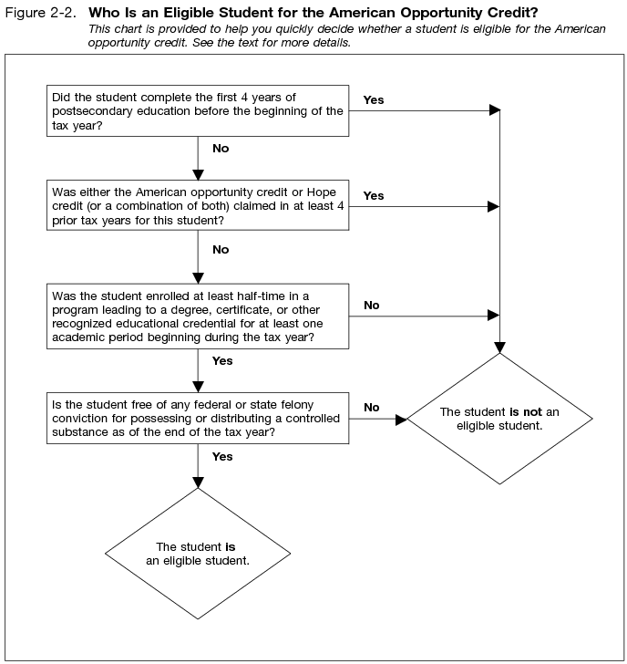
Example 3.
During the 2012 fall semester, Larry was a high school student who took classes on a half-time basis at College X. Larry was not enrolled as part of a degree program at College X because College X only admits students to a degree program if they have a high school diploma or equivalent. Because Larry was not enrolled in a degree program at College X during 2012, Larry was not an eligible student for tax year 2012.
The facts are the same as in Example 3. During the 2012 spring semester, Larry again attended College X but not as part of a degree program. Larry graduated from high school in June 2012. For the 2012 fall semester, Larry enrolled as a full-time student in College X as part of a degree program, and College X awarded Larry credit for his prior coursework at College X. Because Larry was enrolled in a degree program at College X for the 2012 fall term on at least a half-time basis, Larry is an eligible student for all of tax year 2012. Therefore, the qualified education expenses paid for classes taken at College X during both the 2012 spring semester (during which Larry was not enrolled in a degree program) and the 2012 fall semester are taken into account in computing any American opportunity credit.

