Current/Future Adjunct Subject Area Development Scholarship Program
C A P P
cooperative • academic
partnership • program

Who is Eligible for Funding?
Any high school teacher who is currently a CAPP adjunct or who has an educational plan that would allow them to become a CAPP adjunct within one academic year. First consideration will be given to teachers, whether adjuncts or not, who will be eligible to teach a new CAPP course after completing the requested course(s).

What is Eligible for Funding?
The CAPP Subject Area Development Scholarship Program will reimburse adjuncts/future adjuncts for up to 100 percent of the tuition for a single graduate course taken at UW Oshkosh that allows the adjunct to become HLC compliant or is the final course required by your department to reach full adjunct status. The amount of the scholarship will take into consideration the unfunded needs of the student, the impact the course will have on CAPP students in the high school and the amount of money available in the scholarship program. Tuition reimbursement for adjuncts and future adjuncts taking courses from other properly accredited institutions of higher education may be eligible for funding of up to $300 per course (2 courses maximum, $600 total assistance) in the final year of the adjunct’s/future adjunct’s academic program (or for the final two courses that lead to full adjunct status).

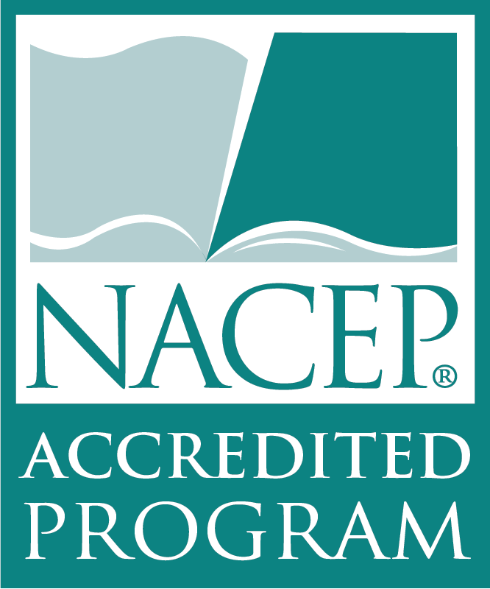

How Do You Apply?
Before taking the course, the applicant should complete an application form and also submit a statement concerning how the requested course scholarship will allow them to teach new CAPP courses and/or support their teaching of current CAPP offerings. A letter of support from the applicant’s school principal for the requested course also must be submitted.
This letter should indicate how much of the tuition burden their school or district funds will cover, and the likelihood of the school offering new CAPP course upon completion of the program/courses by the future adjunct. CAPP scholarship funds will be considered to the extent that other funding is unavailable – matching contributions are favored, but not required.

After You Apply: Applications will be reviewed by the CAPP office and discussed with the appropriate UW Oshkosh academic department. If clarification is needed, the applicant will be contacted. If a positive decision is made, the applicant will receive a letter of commitment for reimbursement of some or all of the course tuition/fees upon successful completion of the course(s) with an “A” or a “B” grade.

Application letter from the adjunct to the CAPP office should include the following for review:

Adjunct Name
Address
Phone/Preferred Email
Home High School
Current adjunct check box (check if yes)
Department/Program if current adjunct
College/University of interest
Course(s) you are interested in enrolling in
Statement of impact on ability to offer new CAPP courses (or HLC compliance) after taking the course(s)
Course tuition
Amount home district is putting towards cost of the course (encouraged)
Amount requested from CAPP ($300 max) if not at UW Oshkosh
Attach letter of support for course from principal/administrator

