SOS Report Instructions

Please use the following link to Titan Web in Google Chrome or Mozilla Firefox to access your SOS Reports and Comments from paper surveys. Safari will not work. Also you can create a personal SOS Folder and save your reports and comments for future use.
https://www.uwosh.edu/registrar/titanweb/
All SOS reports from Fall 2013 to Fall 2015 are found in your Intranet Folder: https://www.uwosh.edu/intranet/

Use your NetID for the log in.

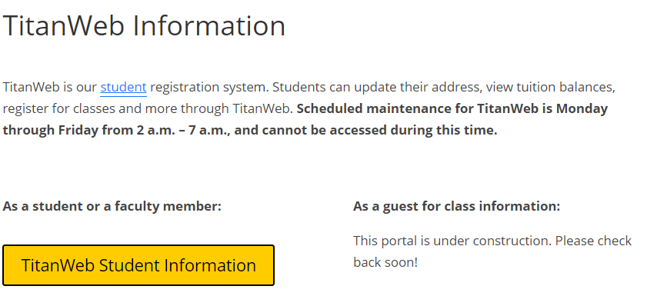
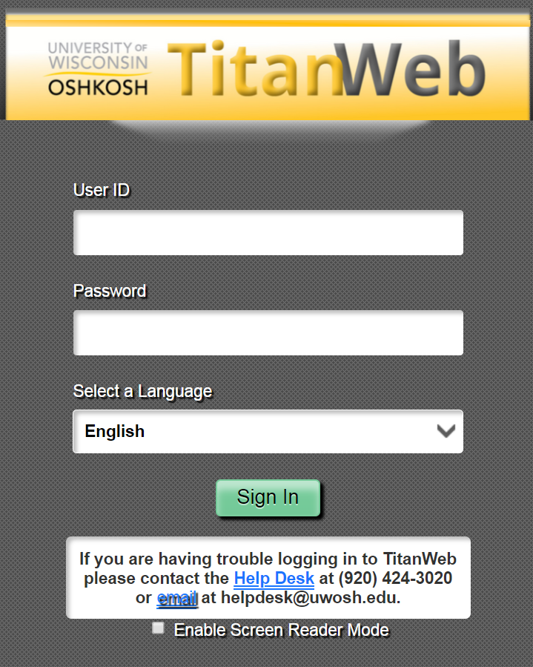
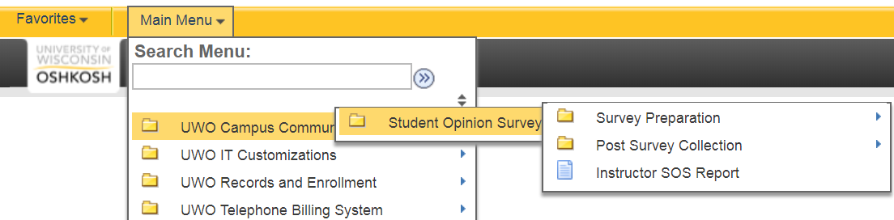

Click on the Search Glass for the Academic Term ID
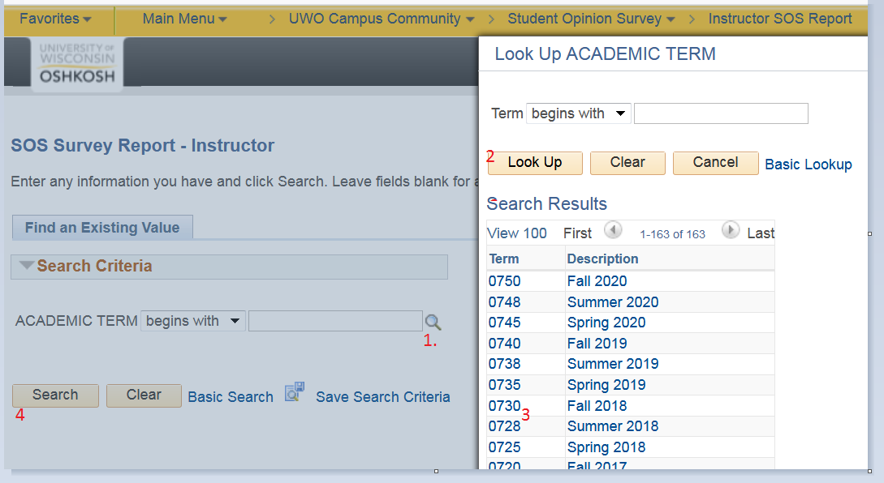

Be sure to use the arrows on the right-hand side to navigate through the sessions and classes
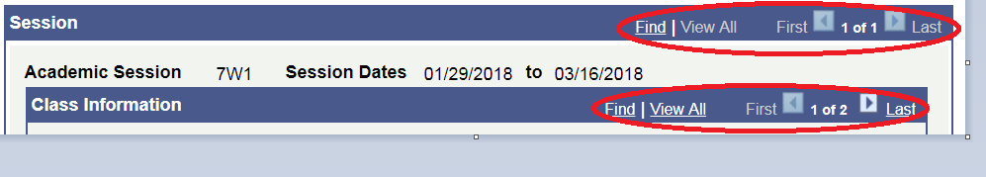
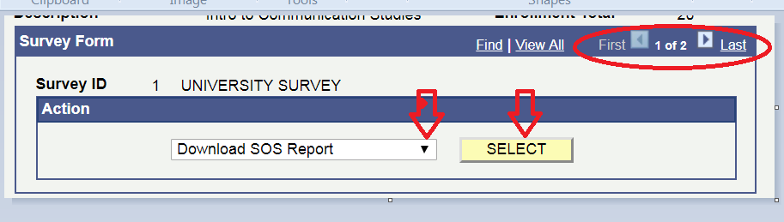

If you don’t see your downloaded SOS report you will most likely have to “allow pop-ups”:
*Directions To Allow Pop-ups in Chrome click on the following link:​
​https://support.google.com/chrome/answer/95472?source=gsearch&hl=en​
Downloads in Firefox:
https://support.mozilla.org/en-US/kb/where-find-and-manage-downloaded-files-firefox?redirectlocale=en-US&redirectslug=use-downloads-window-to-manage-downloaded-files

Please let me know if you have any questions.

