Drug Screen

Drug screen only per Connie School at Kimberly Area School District

A drug screen is required prior to placement with the Kimberly Area School District. Kimberly Area Schools has a contract with Ascension and will pay the full cost of your drug screen. Ascension allows walk-ins but they do prefer that you make an appointment. The phone number for the Menasha location is 920-727-8700.

On the day of your drug screen appointment, please bring:

- Photo ID

Ascension will send the results directly to us.

Ascension Employer Solutions
EMPLOYER AUTHORIZATION FORM

EMPLOYEE |  | Last First Middle |  | Social Security Number
COMPANY |  | Company Name |  | Phone Number
 |  | Kimberly Area School District |  | 920-788-7900
 |  | Authorized By |  | Fax Number
 |  | Connie School, Employment & Benefits Coord. |  | 920-788-7919

CLINIC LOCATIONS – Ascension Employer Solutions
Monday thru Friday  7:30am – 4:30 pm,  Walk-ins Welcome for:  Drug Screen, Audiograms  and TB Skin Test | MENASHA |  | OSHKOSH
 | 1186 Appleton Road  Phone (920) 727-8700  Fax (920) 727-8705 |  | 1855 S. Koeller Street  Phone (920) 223-7075  Fax (920) 223-7105

DRUG & ALCOHOL TESTING
 | 1. Select Testing Authority 2. Select Agency
 | X Non-DOT DOT FAA FMCSA FRA FTA USCG
 | 3. Type of Testing |  | 4. Select Testing Category
 | X Drug Alcohol |  | X Pre-Employment Post-Accident Random
 |  |  | Reasonable Susp. Return-to-Duty Follow-Up

MEDICAL SERVICES
Injury Treatment TB Skin Test Audiogram Respiratory Exam
Free of Communicable Disease Exam DOT Physical Pre-Employment Physical

Other _______________________________________________________________
If a drug test is required with a physical, the employer must also complete the Drug & Alcohol Testing section above.

*** AFTER HOURS DRUG & ALCOHOL TESTING ***
After hours drug and alcohol testing is only available for Post-Accident and Reasonable Suspicion.
If needed for random, the employer must call Affinity Occupational Health to make the arrangements.
After hour  collection fees  apply. | EMERGENCY ROOMS AT:
 | St. Elizabeth Hospital  1506 S. Oneida Street  Appleton, WI 54915  Phone: (920) 738-2105 |  | Mercy Medical Center.  500 S. Oakwood Road,  Oshkosh, WI 54904  Phone: (920) 223-1303
Find Ascension Employer Solutions on-line at
http://www.affinityhealth.org/page/services-specialty-occupational

Appointments available during regular office hours
Monday through Friday, 7:30am – 4:30pm

Ascension Employer Solutions
1186 Appleton Road. • Menasha, WI 54952
Phone (920) 727-8700
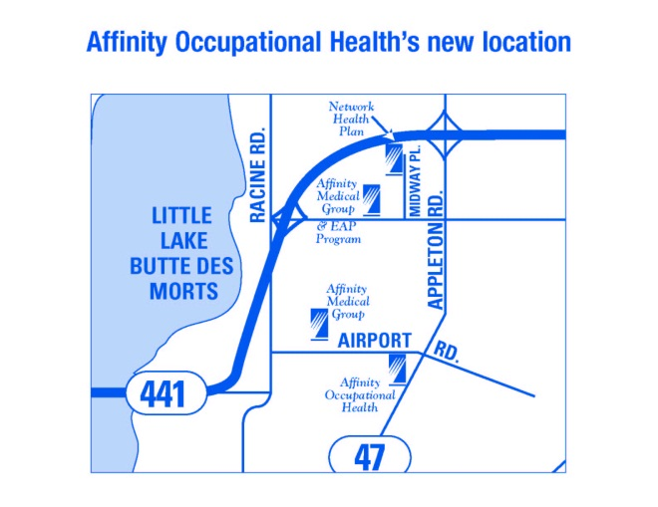

Driving Directions:
From the north: Take Hwy 41 south to Hwy 441 south,
exit Appleton Rd., turn left. Our office is on the right just past
Airport Road.

From the south: Take Hwy 41 north to Hwy 10/441,
exit Midway Rd., turn right. Turn right on Appleton Rd.
Our office is on the right, just past Airport Rd.

Located at the corner of Appleton Rd. and Airport Rd. Across from Kitz & Pfeil True Value Hardware & Menasha Fire Department

Ascension Employer Solutions
1855 S. Koeller St. • Oshkosh, WI 54902
Phone (920) 223-7075
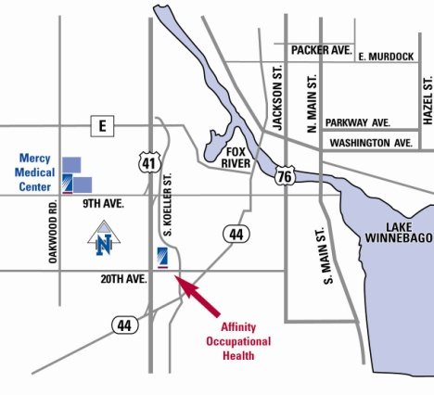
From the north: Take Hwy. 41 south, exit 9th Ave., turn left.
Turn right on S. Koeller St. (travel .9 miles); our
office is on the right.

From the south: Take Hwy. 41 north, exit
South Park Ave./Ripon Rd.(Hwy. 44), turn right. Turn
left on S. Koeller St. (travel 0.5 miles); our office
is on the left. We are in the lower level.

Located in the lower level on Koeller St. in Oshkosh across from Target

Ascension Employer Solutions is dedicated to continually improving the health and
well-being of employees through its partnership with its corporate community and labor force.

