University of Wisconsin Oshkosh
WISDM Training
Debbie Matulle

September 30, 2019

Structure of UW Oshkosh Department Numbers

Example:

102 033130 2

Fund Division Dept. Sub-Dept. Program
(Appropriation)

Comprehensive Universities College of Radio/TV Radio/TV Instruction
Letters & Film Maintenance
Science

Structure of UW System UDDS Numbers

In funding activities, UW System uses UDDS numbers. The UDDS number example that follows is the partner to the UWOSH department number described above.

Example:

UDDS F03-3130
(Unit Division Department Sub-Department)

F = Unit, i.e. UW Oshkosh
03 = Division, i.e. College of Letters & Science
31 = Department, i.e. Radio/TV/Film
30 = Sub-Department, i.e. Radio/TV Maintenance

Appropriation Structure
UW Fund | Title | Budget Category | Fund Type
100 | Non-Appropriated Revenue | GPR | Annual
101 | GPO - Doctoral Cluster | GPR | Annual
102 | GPO - Non-Doctoral Cluster | GPR | Annual
103 | GPO - Colleges | GPR | Annual
104 | GPO - Extension Programs | GPR | Annual
106 | GPO - System Wide | GPR | Annual
109 | Energy Costs | GPR | Annual
110 | Principal Repayment and Interest | GPR | Sum Suff
123 | Principal Repayment - Interest & Rebates | PR | Sum Suff
128 | Auxiliary Enterprises | PR | Continuing
131 | Academic Student Fees | PR | Continuing
132 | Extension Non-Credit Program Receipts | PR | Continuing
133 | Non-Federal Grants and Contracts | PR | Continuing
134 | Gifts - Student Loans | PR | Continuing
135 | Gifts & Donations - WARF | PR | Continuing
136 | General Operations Receipts | PR | Continuing
138 | Sale of Real Property | PR | Continuing
139 | WiSys Technology Foundation Grants | GPR | Annual
144 | Fed aid - Special Projects | PR-F | Continuing
145 | Fed aid - Work Study | PR-F | Continuing
146 | Fed aid - Supplemental Educ Opportunity Grants | PR-F | Continuing
147 | Fed aid - Student Loans | PR-F | Continuing
148 | Fed aid - Basic Educ Opportunity (Pell) Grants | PR-F | Continuing
149 | Fed aid - Direct Student Loans | PR-F | Continuing
150 | Fed aid - Federal Indirect Cost Reimbursement | PR-F | Continuing
151 | Fed aid - Nursing Loans - Undergraduate | PR-F | Continuing
152 | Fed aid - Nursing Loans - Graduates | PR-F | Continuing
160 | Environmental Ed: Environmetal Assessment (274) | SEG | Continuing
161 | Endowment Trust Fund Income (876) | SEG | Continuing
162 | Endowment Trust Fund Operations (875) | SEG | Continuing
164 | Environmental Education: Forestry (212) | SEG | Annual
167 | Wisconsin Bioenergy Initiative (274) | SEG | Annual
168 | Extension Recycling Education (274) | SEG | Annual

UW Fund | Title | Budget Category | Fund Type
170 | Environmental Program Grants and Scholarships (745) | SEG | Continuing
171 | Humanities Council | GPR | Annual
180 | Emerging Technology | GPR | Annual
183 | Extension Outreach | PR-S | Continuing
184 | License Plate Scholarship Programs | PR-S | Continuing
185 | Center for Urban Land Economics Research | PR-S | Continuing
187 | Funds Transferred From Other State Agencies | PR-S | Continuing
189 | Extension Student Fees | PR | Continuing
191 | Telecommunications Services (285) | SEG | Annual
198 | General Fund Interest - Block Grant | PR | Continuing
228 | Auxiliary Enterprises - Capital Projects | PR | Continuing
231 | Acad Stu Fees Carryforward Contributions (Budgetary Only) | PR | Continuing
233 | Gifts - General | PR | Continuing
301 | GPO - System Administration | GPR | Annual
402 | Minority and Disadvantaged Programs | GPR | Annual
403 | Graduate Student Financial Aid | GPR | Annual
406 | Lawton Minority Undergraduate Grants Program | GPR | Annual
902 | Sales Tax Clearing | REV | Continuing
904 | Reserve for Federal Tax Withholding | REV | Continuing
963 | Clr - Sale Surplus Property | REV | Continuing
966 | Advanced Academic Student Fees | REV | Continuing
980 | Employer's Share Fringe Benefit Clearing | REV | Continuing
990 | Revenue Clearing Account | REV | Continuing
991 | Travel Advance | REV | Continuing
993 | Contingent Fund | REV | Continuing
997 | Unpaid Salary Deductions | REV | Continuing
998 | Deductions From Salaries-Optional Deductions | REV | Continuing
999 | Insurance Loss | REV | Continuing

Appropriation Structure Definitions

General Purpose Revenue - General purpose revenues consist of general taxes, miscellaneous receipts and revenues collected by state agencies which are deposited into the general fund, and are available for appropriation by the legislature.
Program Revenue - Program revenues consist of revenues which are deposited into the general fund and are credited by law to an appropriation to finance a specified program or state agency.
Segregated Funds - Segregated fund revenues are revenues, which by law, are deposited into funds other than the general fund and are available for the purposes for which such funds are created.
Program Revenue-State - State revenues are moneys received from the state government which may be deposited as program revenues in the general fund.
Program Revenue-Federal - Federal revenues are moneys received from the federal government which may be deposited as program revenues in the general fund or as segregated revenues in the segregated fund to finance specific purposes.
Revolving - Non-budgetary appropriations not specifically established for each agency in the Chapter 20 budget schedule. There are two types: 1) Custody funds, established to allow agencies to collect and disburse moneys that are payable to persons other than the state; and 2) Clearing funds, only to be used when, at the time of receipt or disbursement, the state agency does not have sufficient information to distribute the revenue or expenditure to the appropriate Chapter 20 appropriations.
Annual Appropriations - An authorization that is expendable only up to the amount appropriated by the Legislature and only for the fiscal year for which it is appropriated. Amounts appropriated but unexpended or unencumbered generally lapse to the fund from which they are appropriated at the end of each fiscal year.
Biennial Appropriations - An authorization that is expendable only during the biennium for which appropriated by the Legislature. The amounts appropriated for each fiscal year represent the most reliable estimates of the amounts, which will be expended in each fiscal year. For accounting purposes, the appropriation for the first year of a biennium is the sum of the expenditures for that fiscal year plus the encumbrances at the close of that year. The appropriation for the second year is the unexpended and unencumbered balance of the appropriation at the end of the first fiscal year. Amount appropriated but unexpended or unencumbered at the end of a biennium lapse to the fund from which they were appropriated.
Continuing Appropriations - An authorization which is expendable until fully depleted or repealed by subsequent action of the Legislature. The appropriation for any fiscal year consists of the ending balance from the previous fiscal year plus the revenues received or the new appropriation authority granted in the current fiscal year. Specific dollar amounts appearing in any type of appropriation listing or schedule only represent the most reliable estimates of the amounts to be expended or encumbered during any given fiscal year and are not considered as limiting.
Sum Sufficient - An authorization which is expendable from the indicated source of funds in the amounts necessary or sufficient to accomplish the purpose for which provided. The amounts appropriated represent the most reliable estimate of the amounts that will be needed for the stated purpose.

For more information on Appropriation/Fund Structure please visit the UW System website:
https://www.wisconsin.edu/financial-administration/accounting-and-budget-control/chart-of-accounts/

Program Codes

Program codes are mandated by UW System Administration, and based on the Financial Accounting and Reporting Manual for Higher Education (published by the National Association of College and University Business Officers). The codes are used as the basis for assigning program costs in preparing the annual, base operating budget. The codes commonly used on the UW Oshkosh campus are listed below and typically are placed as the last digit of a department number (see “Structure of UW Oshkosh Department Numbers”).

Program Code Description | Program Code # | Includes
Student Services | 0 | Student Services Administration, Administrative Data Processing-Student Services, Social and Cultural Development, Intercollegiate Athletics, Counseling and Career Guidance, Financial Aid Administration, Student Admissions, Student Records, Student Health Services, Child Care Services, Educational Opportunity, Transportation Services, Mandatory Transfers/Debt Service
Institutional Support | 1 | Executive Management, Fiscal Operations, General Administration and Logistical Services, Administrative Computing Support, Public Relations/Development
Instruction | 2 | General Academic Instruction, Preparatory/Remedial Instruction
Research | 4 | Individual, Project, Institutes and Research Centers Research Activities Organized to Produce Research Outcomes
Public Service | 5 | Outreach Education, Community Service, Cooperative Extension Service, Public Broadcasting Services
Academic Support | 6 | Libraries, Museums and Galleries, Educational Media Services, Academic Computing Support, Ancillary Support, Academic Administration, Academic Advising, Academic Personnel Development, Course and Curriculum Development
Physical Plant | 7 | Physical Plant Administration, Facilities Planning and Capital Budgeting, Building Maintenance, Custodial Services, Utilities, Grounds Maintenance, Major Repairs and Renovations, Other Services, Mandatory Transfers/Debt Service
Auxiliary Enterprises | 8 | Self-Supporting Programs Furnishing Goods or Services to Students, Faculty or Staff; Mandatory Transfers/Debt Service
Financial Aid | 9 | Scholarships, Fellowships, Loans

For more detailed information about program codes, visit http://www.uwsa.edu/fadmin/activity/index.htm .

GPR/PR Funding Comparison

 | GPR – General Purpose Revenue | PR – Program Revenue and  PRF – Program Revenue Federal
Current UW-Oshkosh Funds: | 102,103, 104, 109, 402, 403 | 128, 123, 131, 132, 133, 136, 144, 145, 150, 228
Origin of the Funds: | State appropriation; biennial budget allocation | Self-sustaining; revenue to finance specified programs
Fund Composition: | Currently, UW Oshkosh receives an annual budget allocation for salary, fringe benefits and supplies and expenses from UW System. While individual divisions do not budget fringe benefits in the annual budget process, as an institution we are assessed additional fringe benefit expenditures if actual salary expenditures exceed our annual salary budget allocation. | Responsible for fringe benefits expenditures
Salary Pay Plan: | Typically receive budget allocation from UW System for salary pay plans.(excluding non-continuing appointments and LTEs)  Please note: Pay Plans are partially funded from tuition increases. If there is a tuition freeze, the institutions and UW System are responsible for making up the difference. | Must increase revenue stream to cover salary and fringe benefit pay plans
Carryover: | UW System sends the official carryover letter for approval from UW Oshkosh. Carryover comes as one-time supplies and expense budget authority and is distributed by an approval process on Campus | Fiscal year end cash balances are uploaded to WISDM by UW System and reflected as prior year cash balance.
Budget Planning: | A budget allocation is provided by UW System and distributed by UW Oshkosh to divisions and departments. The allocation is broken down by salaries and supplies and expenses. A budget planning/submission memo is provided to the campus. | All costs associated with delivery of a PR funded program are covered by that program. A guideline for budget planning is included in the annual Auxiliary Cost and Budget Building Factors memo from UW System.

Basic Search of an account:

- Log into WISDM with you Net ID & Password https://uwosh.edu/finance-administration/financial-services/
- Hover over the “Main Menu” tab on the top left corner
  - Hover over the “Departments” tab – the first in the drop down list
  - Click on Search
- Enter in the Fund (3 digit number), the Department/Dept (6 digit number)
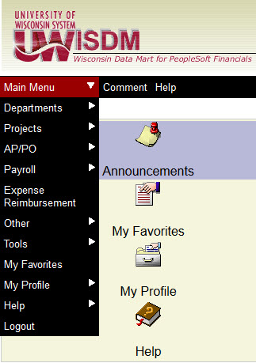
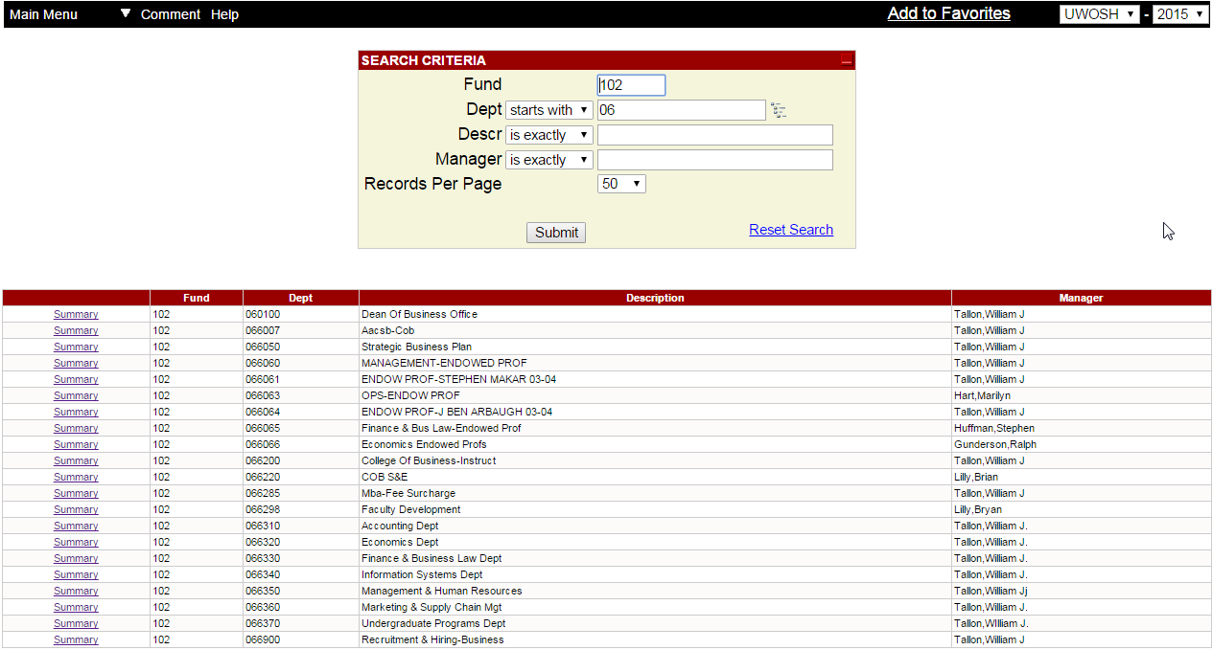
- Click the submit button
- This is your main WISDM screen
- Change the Drilldown Level to “Details” to get more information
  - The “Account Type” Drilldown Level provides you with the basics of your account.
  - The “Details” Level provides specifics as to what your expenses and revenues entail.
- Change the Account Tree to ACCOUNT_NO_FRINGE for all 102 Funds
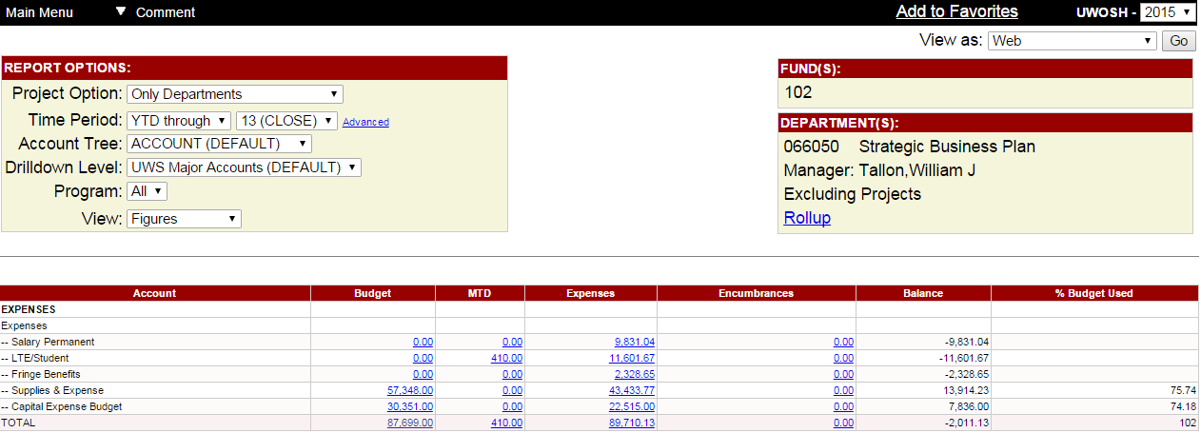
  - 102 fringes are currently covered by UW System
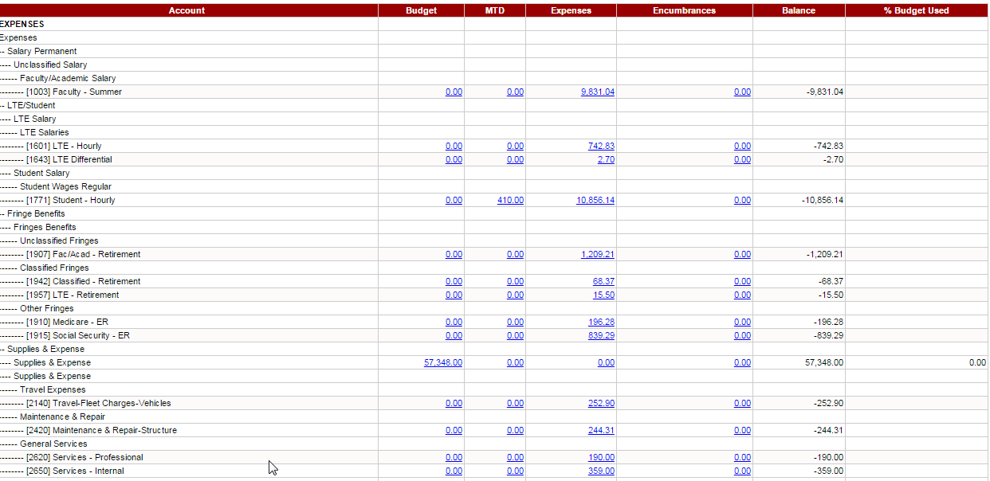

Account:
The specific area within your budget where your charge/revenue is being placed. This provides specifics as to where you’re spending your money.

Ex: Student Salary, Unclassified Fringe Benefits, Supplies, Computer Equipment, Travel Expenses, Telephones, Maintenance & Repairs

**To look up the Account Codes for each Fiscal year please visit the UW System Account Code website: https://pollux.uwsa.edu/PRODUCTION/acctcodes/index.php/acctcodes/acctcodeselection/2015
Balance:
Total Amount left in your Account after deducting your “Actuals” from the budget provided.
Budget:
The amount allocated to your department by the Redbook Budget (from the State.)

Anything in this column is money you have been given to spend throughout the fiscal year.
Actuals:
All charges made to your Account within the current Fiscal Year.
MTD:
Month To Date Charges made on your WISDM Account.

Looking Up Transaction Details

- Click on the “Actuals” Amount under the expense/revenue you want to look up.
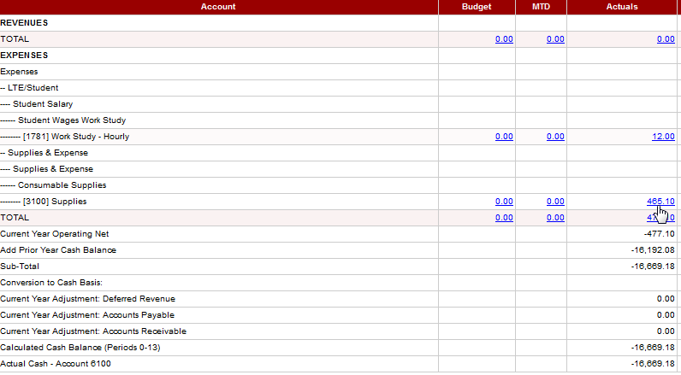

- This will bring up a list of all items purchased this fiscal year along with their descriptions
- To get more information regarding the purchase click on the Voucher ID link next to the purchase you are inquiring after.
Voucher ID: The number given your transaction when it is entered into SFS for payment.

When you click on this link it brings up further information regarding the purchase: Vendor name, Payment Reference/Invoice, Payment Date, and Status
Journal ID: The ID of the Department/
Division who added these charges to your Account.
Ex: Accounts Payable added these charges.
This is your WISDM Funding String – the one you entered to search for your Department’s Account
Your Account # is where in your Account the charge/revenue will go. Ex: Supplies, Computer Equipment, Meals, etc.

Description of what the charges are for

Oshkosh Journal Names

CBBKSTORE | Bookstore | Nicole Bourassa #2262
CBBUDGET | Budget Office | budgetoffice@uwosh.edu
CBBULKMAIL | Postal Services | Troy Hart #1145
CBCCDET | Ctr for Career Dev & Training | Kim Stuyvenberg #1113
CBCOPIER | Document Services | Patti Adkins #1122
CBEXPRESS | Postal Services | Troy Hart #1145
CBFACMGMT | Facilities chargebacks (work orders) | Angel Liddle #2144
CBFAX | Postal Services | Troy Hart #1145
CBFUEL | Facilities Monthly Fuel chargebacks | Mary Zwicke #0343
CBGRANTS | Grant | Mai Kar Lee #2449
CBINFOSYS | PC Support charges | Jenny Hoerth #4480
CBLABEL | Postal Services | Troy Hart #1145
CBMISC | Miscellaneous Transfers | Michelle Highley #0837
CBPARKING | Parking Transfers/Parking Services | Dana Hartel #4455
CBPOSTAGE | Postal Services | Troy Hart #1145
CBREEVE | Reeve or Copy This charges | Matt Suwalski #2079
CBRESLIFE | Residence Life, Laundry, or Chord charges | Paula Zemke #0942/Adam Hernandez #1720
CBSTLOANS | On-line Payment Processing | Rachel Grose #1336
CBSTORES | Custodial and Central Stores Supplies chargebacks | Angel Liddle #2144
CBTELECOM | Telecommunications chargebacks (Data lines, jacks, etc) | Jenny Hoerth #4480
CBTRAVEL | Travel advance charges to departments | Michelle Highley #0837
CBTTRS | Transfers | Michelle Highley #0837
CBUNEMPLOY | Unemployment | Debbie Matulle #3318
CBUPS | Postal Services | Troy Hart #1145
CBUTIL | Utilities – Electricity and Heat | Angel Liddle #2144
POADJ | PO Encumbrance adjusting entry | Brian Klinger #0317
VISA | Bi-weekly VISA charges | Brian Klinger #0317
IUJ | Transfers between UW Institutions | Debbie Matulle #3318

**If you have questions on charges contact the department associated with the Journal ID/Name**

For addition information, see UW System FAQs
https://www.wisconsin.edu/sfs/reporting/wisdm-and-wiser/wisdm-faqs/

For information on WISER:

- WISER AP-PO Search docx
- WISER Department Search docx
- WISER Payroll Search docx
- WISER Project Search docx
- WISER Transaction Search

