April 2, 2021
To: All Staff and Faculty
From: Jesse Crain-Director of Purchasing
RE: Shop UW+ Shopper Training

Greetings: With the ShopUW+ platform scheduled to be enabled on April 16th, we are beginning the process of offering training to all of our campus users. Those of you designated as a Requestor or an Approver will be receiving a separate message from UW System regarding your specific training.
All other Faculty and Staff that have NOT been assigned the Requestor or Approver roles are automatically assigned the Shopper role. The training for the Shopper role will be provided through the ShopUW+ Essentials website. This training will be available starting on Monday, April 5th. Please use the link and instructions below to access your training. A copy of the ShopUW+ Essentials link is also available on the UW-Oshkosh Purchasing Website.

Getting Started

The ShopUW+ Essentials (https://shopuwplus.wisc.edu) website will be your hub to access training, resources, and support. ShopUW+ Essentials will go live April 5. This site will not be active before this date. For future access, you will want to bookmark the new ShopUW+ Essentials website address.
We strongly encourage you to complete your training before using ShopUW+. After April 5, go to ShopUW+ Essentials to get started by watching the short informational video called Preparing for ShopUW+ to get an overview of the platform and the training courses. You can then self-enroll for your courses.

The following courses will support you in your Shopper role. The courses will be delivered through Canvas. We strongly encourage you to complete these courses before using ShopUW+. Completing the training should take under two hours.

Course | Available
ShopUW+ Foundations | 4/5
ShopUW+ Process Updates | 4/5
ShopUW+ Shopper Skills | 4/12

Enrolling in ShopUW+ Courses
You will need to self-enroll in your courses. Go to the ShopUW+ Essentials Getting Started page. Follow the steps under How to Self-Enroll in Training.
You can also access your courses after you self-enroll through the ShopUW+ Essentials website after April 5. If you see a notification at the top of the screen informing you that you have been invited to join a ShopUW+ Course as a student, click Accept.

- If you access Canvas and do not see the expected courses, please verify that you are in the correct Canvas site by checking that the page starts with uws.instructure.com.
- If you do not see the correct courses or have any trouble accessing them, email Customer Support at uwsaproblemsolvers@uwsa.edu.

Returning to Courses

- You will always be able to log in to your training from the ShopUW+ Essentials website.
- You can also log in through Canvas training, which will be hosted at uws.instructure.com.

Training Tips

- If you revisit training after ShopUW+ launches on April 16 and have two monitors available, use one monitor for watching the training demo/short videos and the other to follow along in the platform.
- Completing the training should take under two hours. You may revisit the training as many times as you would like before and after ShopUW+ goes live.

Finding Answers

As you complete your ShopUW+ training, review the Quick Reference Guide. You will find step-by-step instructions to complete more than 50 processes, with a summary, standard navigation options, and screen shots to guide you as you begin working in ShopUW+. The Quick Reference Guide will answer most of your questions about using the new platform. You can also find other useful information on the ShopUW+ Essentials website.
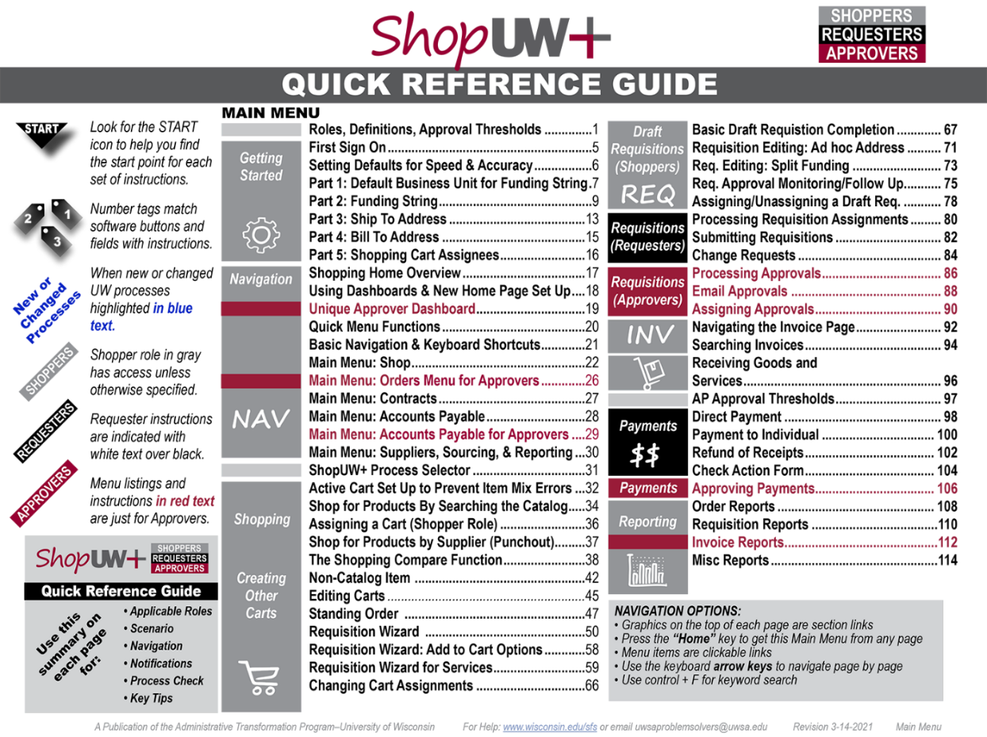
DRAFT
Assistance using ShopUW+
We are currently working to resolve accessibility barriers in ShopUW+. To learn about the accessibility and usability of ShopUW+, go to ShopUW+ - Accessibility and Usability Information KB.
If you need accessibility assistance, want to report an accessibility barrier, or if you are having difficulty using ShopUW+ or any of the training materials, email our Customer Support team at uwsaproblemsolvers@uwsa.edu.

Enjoy the new shopping experience

For the best experience as you make this transition, complete your assigned training in order before you begin working in ShopUW+. Understanding the tool and workflows will help you work confidently and more quickly.

Thank you

