Cost Transfer Workflow Tool

April 2120
Table of Contents
Cost Transfer Workflow Tool Introduction 4
What is it? 4
Purpose of This Training Document 4
Resources 4
Cost Transfer Tool Overview 5
Features 5
SCT vs. NSCT 5
Data Entry 6
Validations 6
Workflow 7
Person Resolution 10
Other Aspects to Workflow and Approval 10
Cost Transfer Workflow Tool User Instructions 12
Roles 12
Instructions for Preparers of Non-Salary Cost Transfers: 13
Creating a New Non-Salary Cost Transfer 15
Add a Transfer Set 16
Search Screen for “From” Transactions 17
Entering the “To” Side of the Cost Transfer Transaction 19
Checking for Errors 20
Documentation Tab 21
Documentation/Comments/Justification for Transfers 90 Days After the Original Transaction 22
NSCT Routing, Edit Rights and Ownership 23
Submitting NSCT Requests for Approval 24
History of the Transfer 25
Salary Cost Transfers for Preparers 26
Create SCT Detail 27
SCT Approvals 35
SCT History 36
Instructions for Division Approvers 37
Approvers’ Dashboard View 37
Delegating Signature Authority 38
Email Notification to Approvers That a Cost Transfer Requires Approval 39
Viewing the Details of a Cost Transfer 40
Accounting / Coding of Non-Salary Cost Transfers 41
Justification for Transfers 90 Days After Date of Original Transaction 41
Collecting Signatures 42
Email Notification: Sponsored Program Office Send-Back to Division 43
Manage Approvers 44
Manage Division Access 46
Manage Sponsored Programs Approvers 47
Manage Effort Approvers 48
Manage Work Study Approvers 49
Manage Property Control Approvers 50
General Information 51
Sign In 51
Sign Out 52
Home 53
Searching for Transfers 54
Send A Comment/Support 56
Preferences 61
About 62
Session Expired 62
WISER Journal 63
Starting with WISER 64
Salary Cost Transfer Tool Application Administration Manual (UWSA SFS Only) 67
BU Setup 67
Manage Users 69
Manage Announcements 71

Cost Transfer Workflow Tool Introduction

What is it?

A web-based cost transfer tool that will process Non-Salary and Salary Cost Transfers, making a balanced transfer from one funding source to another.

Purpose of This Training Document

To clarify the key similarities and differences between the workflow of the existing non-salary cost transfer process and that of the new electronic workflow tool
To provide users with guidance to navigate through the features of the new tool
To provide new users with enough information to successfully use the Cost Transfer Workflow Tool

This document has been created specifically to be used as a reference. The assumption is that our intended audience is already familiar with the important concepts and policies associated with cost transfers including but not limited to terms and definitions, allowable and allocable costs, and fiduciary responsibilities. This document is not intended to replace any existing cost transfer policies.

Resources

There are several resources available to help you progress through the Cost Transfer Workflow Tool that you can use when you encounter problems, have specific questions, or desire to provide feedback:

- Help Icon: for immediate assistance, click on the help icon found on most screens within the Cost Transfer Workflow Tool itself. Many of your questions may be answered right here.

- Cost Transfer Support: Each institution has SFS users who are more familiar with the process and procedures for doing Cost Transfers. Find your institutional support contact on this website: https://www.wisconsin.edu/sfs/institutional-support-contacts/.

- SFS Documentation and Training Page: The SFS group at UWSA maintains documentation on how the SFS Cost Transfer Tool functions. You can find it by following this link, to the SFS web page. Cost Transfer Tool documents can be found under the “GL – General Ledger” subsection.

- SFS ProblemSolvers: issues with the functionality of the SFS system can be escalated to the UWSA ProblemSolvers, a group at UWSA which maintains and provides advanced help for SFS. This level of support is provided to help if SFS institution support personnel can’t solve your problem.

- Send a Comment/Support: Click on this link at the bottom of your screen to provide feedback or seek assistance from SFS Problemsolvers.

Cost Transfer Tool Overview

Features
The Cost Transfer Tool is designed to make a balanced transfer of accounting from one funding source to another. It delivers the following high-level features:
- Captures necessary metadata about the transfer such as initiator, date, reason justification comments, documents (attached files), end-user comments, and information about jobs (if SCT).
- Gives the user the ability to search WISER (through a simplified interface) to select transaction(s) that need to be transferred, thus eliminating the possibility of creating transfers for data that never existed in the GL. This step also eliminates the tedious entry of most of the data allowing the preparer to simply focus on where the funding is being transferred to.
- Validation of the data is also important where combo edits from SFS are applied, sponsored programs checks, and other smaller validations are performed to ensure the data is clean and valid when going to the GL.
- Provides a custom workflow system that requests signatures for approval of the transfer based on the content of the transfer itself. For example, if a sponsored program is used in the Project ID field, more advanced workflow is selected to grab signatures for people attached to the project.
- For non-salary cost transfers, after approval, the transfer is automatically interfaced to the GL via the Journal Entry Tool (JET). This happens by leveraging the backend of JET so that no human data entry is required. For SCT, a different process is used to format the transfer so that it is ready to be keyed into the HRS Direct Retro system. Due to the technical complexity, no direct HRS interface is provided.
- The tool also provides search features so users can find transfers they’ve made in the past.
- Integrates to WISER so that when looking at a transaction in WISER, a transfer can be initiated right from the reporting system. The transaction is loaded into Cost Transfer Tool and basic metadata is requested. This allows users to initiate a transfer when they see the need in the system where they are examining data from rather than looking in WISER and then repeating the same search in Cost Transfer Tool. This works for SCT and NSCTs.

SCT vs. NSCT

Cost transfers are divided into two forms – salary and non-salary. Each cost transfer has a transfer number which acts like a unique business key. Salary transfers begin with “S” and non-salary begins with “N” followed by a unique sequence number.
Salary transfers tend to be more complicated because they require capturing specific job information and work more on the salary payment/pay period unit-of-work rather than the journal line-level unit-of-work. Salary transfers take longer to process because there is no direct connection between the tool and HRS. They can also involve more workflow rules because of effort reporting (which is specific to sponsored programs).
Non-salary transfers involve selecting lines from the GL. This process is made possible because of WISER. The tool searches the WISER database based on criteria entered by the user to allow them to make a selection. “From” accounting lines are automatically generated based on these selections. A user can elect to transfer the full or partial amount of the “from” accounting and can also choose to move that amount to one or more “to” lines that receive the negation of that amount. This creates a perfectly balanced journal every time. NSCTs also can be interfaced directly to the GL through the JET application programming interface (JETAPI). This can save a great amount of time in the entry and posting process (in fact, some NSCTs can appear in the GL the same business day as they are initiated).

Data Entry

There are many convenient tools to aid in entry:
- Upon login, users see work lists such as any transfers routed to them, open transfers that are in process of approval or posting, transfers one must sign, and completed transfers. Accounting Office also sees work lists for SCTs that need entry in HRS and any transfers that failed JET interfacing and need to be retried.
- Look up tool allows one to see the full transaction detail from WISER data without going to WISER or query tool.
- “From” side is locked except for amount. User can perform a partial transfer if desired.
- “To” side can be split so that a single “from” line can move to multiple destination funding sources.
- A copy all tool exists so that if one needs to do many lines in a transfer where the “to” side is all the same funding (for example, to move N charges from department X to department Y).
- Transfers can be marked urgent to signal to approvers that this transfer must be expedited. Urgent transfers automatically make it to the top of work lists.
- Error messages are presented clearly in a summarized format.
- At any time, a user can check validations to see if they have any mistakes – they do not need to submit to see these errors.
- Debits and Credits are listed for reference to ensure the transfer is balanced.
- Comments can be entered in the Documentation tab to further explain the transfer.
- Files such as PDFs or XLSX can be attached to the transfer along with a note for each.
- 90-day justification questionnaire will appear for transfers that are beyond the 90-day justification time period for sponsored programs.
- Routing exists to send the transfer to a person for review/correction. This basically sends the record to a person and gives them editing rights over it. Along with the comments system, this can facilitate on-the-record conversations between staff members to resolve issues or justify a transfer. Routing can be to any person at the institution.
- A complete history is kept of all status changes and who a record was routed to, etc.

Validations

Both SCTs and NSCTs undergo a series of validations to ensure that all data is valid and clean. The following high-level validations are performed:
- SFS combo edits are invoked. All required chart fields are checked, combination rules are applied.
- Debits and credits must be equal.
- Line descriptions must be filled in.
- The “from” amount cannot be greater than the original posted amount and cannot be zero.
- The transfer cannot be empty (it must have at least one set of balanced transfer items).
- Sponsored and non-sponsored projects cannot be mixed in the same transfer. For example, a sponsored project cannot be in set 1 of a transfer and then a non-sponsored is in set 2. A sponsored set can transfer to a non-sponsored project in the same transfer set (such as moving to a gift project).
- For sponsored programs, any transfers older than 90 days must have a standard 90-day justification form filled out. Cost Transfer Tool makes this form available electronically and captures the data. This only applies to transactions on certain sponsored funds.
- Transactions cannot be transferred a second time. For example, if 100% of the amount of an original transaction is transferred, the tool keeps a record of this and disallows any further transfer. Any remaining amount from a previous partial transfer is eligible to be transferred, however.
- Budget accounts, balance sheets (such as liabilities, deferred expense, AR, etc.), or revenues accounts are not allowed. In other words, it must be an expenditure.
- For NSCTs, salary account codes are not allowed.
- For SCTs, non-salary account codes are not allowed.
- The sign of the “from” amount must be preserved in the negated form (for example, if the original posting was for $1, the “from” amount must be -$1.). This prevents the user from flipping the sign accidentally.
- Transfers are limited to 50 total sets. Transfers larger than this usually must be handled via a custom journal posting through JET via Accounting Office.

If any of these rules are violated, the tool informs the user and halts any further processing until the corrective actions are taken.

Workflow

Once the transfer completes all entry and passes validations, it then moves on to the next step – approval in the form of human review. The general high-level lifecycle of the transfer is as follows:
User Entry Wait for Approvals Pending Posting Posted/Complete
The approvals process is dynamic and depends on the content of the transfer itself. For example, the use of sponsored projects changes the approval process when compared to a simpler department to department, non-sponsored transfer.
One core concept in CT workflow is the idea of an approval “tier”. A tier is essentially a role-level where one or more signatures is required to collect to close the tier. Tiers are ordered so that the first tier must be fulfilled before the second tier, and that must be fulfilled before the third and so on. This ensures that the high-level tiers do not see the transfer on their work lists until it is ready for them to sign. Upon a rejection, the rejection usually goes to the previous tier where it must be corrected or deleted by the preparer. Each tier can collect 1 or more signatures which is usually dependent on how complicated the transfer is.

The following is a flowchart diagram of the rules:

YES
Suspense Account?
Add Sponsored program Supervisor Approvals/Grants Accountants
Work Study? (fund 145)
Add Work Study Approvals
Sponsored?
Add Division Approvals
Add PI Approvals
Fund is not 142?
Add Sponsored Program Approvals
Salary transfer and effort certification open period used?
Add Effort Reviewer Approval
YES
YES
YES
YES
NO
NO
NO
NO
NO
NO
DONE
BU Central Office Approver (final)

After the software goes through this decision process, a list of approval items is generated. An approval item is like a line on a contract that has a role on it but no signature yet. These approval items are generated from the orange boxes in the diagram. The approval items each have a “tier” associated with as discussed earlier. This is essentially a number so that the approval items can be sorted in the right order so that the first tier is first, etc.
Here is an example of a hypothetical cost transfer and what the approval manifest will look like:
- User transfers payroll for a semester for a grad student to new sponsored project from an old sponsored project. The two projects have different PIs. User submits and passes validation.
- The calculation of the required approvals commences:
  - Since the transfer involves sponsored projects, two PI approvals are computed since there are two different PIs. This is tier 1.
  - Next, a lookup is performed to see who can sign at Sponsored Program Office for these projects. It is found to be the same accountant for both so only one approval item is generated. This is tier 3 (the generation of the approval item is not necessary done in order – it is done this way for convenience in the code – this is an implementation detail).
  - Since an effort certification period is not in progress at this time, no effort reviewer is needed.
  - Next, the division is found on the transactions and happens to be the same for both. This uses alphabetical range to compute. The division approval item is added. This is tier 2.
  - A total of four signatures will be required: 2 PIs, 1 Division, 1 at Sponsored Programs.
- The first tier opens (PIs) and both PIs receive e-mails informing them of signature requirement. They both sign eventually, and this closes tier 1.
- Tier 2 opens, and division receives the notification. They sign as well closing tier 2.
- Tier 3 opens, and Sponsored Program Office receives the notification. They sign finalizing the transfer.
- The transfer moves to Waiting to Post. Since it is a SCT, Accounting will now find this transfer on their work list of entry to HRS. This list is monitored by staff daily and worked on.
- The HRS entry is performed and the Accounting staff member closes the record in Cost Transfer as Complete. They associate the DR number (direct retro ID) to the transfer record for auditing purposes.
Here is another, simpler example:
- User makes a simple non-salary transfer from one department to another in the same division. The transfer passes validation and is submitted for approval.
- Since no sponsored projects or work study is involved, the division is the only approval item generated.
- The division representative signs finalizing the approvals.
- Since all signatures are collected, the transfer moves to Waiting to Post state.
- The transfer is interfaced through JET to SFS. It will be posted in the next run of the posting job (usually within 15 minutes during business hours).
- The Journal ID is associated with the transfer for auditing purposes. The transfer is automatically completed when the JET interface is successful.

Here is a high-level explanation of each decision box (blue boxes) in the above diagram:
- Suspense Account – Sponsored Program Office maintains a table of special suspense accounts (project IDs) that when used will trigger this rule. This is a special use case of the tool and is primarily used by sponsored programs and not typically visible to most users.
- Work Study – this is defined by the user of fund 145 on any transaction line (from or to line).
- Sponsored – this is defined by the existence of a valid project ID on a line and the fund of that line being either 133, 142, or 144. Fund 142 must have PI approval but does not require sponsored program approvals or effort review.
- Effort Review – this is complex decision based on the pay periods used in an SCT and whether they fall within a specific effort review calendar range. This range is stored in a table in the transfer tool’s database. It is not currently end-user maintainable.

Person Resolution

The final component of the workflow process is person resolution. This refers to the process that the tool uses to resolve who can sign on a given approval item. Each approval item has a role associated with it (such as PI, Division, etc.). Each role requires a different technique to look up how to find people that can sign. This drives how e-mail notifications work and security for determining if a given user is able to sign or not.
It is important to note that when each new tier opens, the resolution process runs. This means that the approval item is not tied to a specific person until they sign. The person or persons that are determined to sign is delayed until the last possible moment and is not computed ahead of time (for example at the submission of the transfer).
For each distinct role, here is a breakdown of how the resolution process is determined:
- Division – the tool maintains a table of divisional dept. ranges that map to employees that work in the division and what dept(s) they can sign for. This table is maintained centrally by the institution’s Accounting Office. Each division can divide their workload however they desire.
- PIs – the tool looks up the connection between Project ID and PI from a WISER data source. This is defined in SFS when the project is setup. Since there is a day delay between when an entry is added/edited in SFS and WISER’S extract of that data, this might not be completely current and can lead to a subtle problem. There is no workaround to that except to wait another business day.
- Sponsored Programs – in SFS there is a connection between “billing specialist” and the award/project. WISER has this data as well, however, the connection between billing specialist and actual employee ID is not defined anywhere in SFS or WISER. The tool utilizes a crosswalk table that maps billing specialist ID as defined in SFS to employee ID. This table is maintained by Sponsored Program Office and must be kept up to date to be as accurate as possible whenever staffing changes.
- Sponsored Program Supervisor – same as sponsored programs but has a supervisor flag attached to the person’s account. This is used for suspense account functionality.
- Effort Reviewer – defined in a table as well. No end-user or administrative page has been written to change this. DoIT must perform data update if this changes.
- Work Study – defined in a lookup table. Accounting Office can edit this table with an admin page as needed.
At the time when a tier opens, the approval items for that tier are found and then each approval item is run through the person resolution process. Ultimately, a list of people is generated and the e-mail addresses on file for those people are used to send a notification to sign.

Other Aspects to Workflow and Approval
- When a record is rejected and goes back to be edited, upon submission a second time, existing signatures made prior to rejection are preserved. The system “fast-forwards” to the highest, unsigned tier at that time. This was done to avoid tasking PIs with signing a second time when a minor accounting correction took place. Sponsored Programs in this case ultimately ensures the transfer is valid and appropriate.
- It is possible for a division approver to make his/her own transfer and sign it as well. There is no conflict of interest considered.
- If person resolution resolves to a project with CHAIR or DEAN (a generic term) listed as the PI, no actual person can be resolved and so PI approval is not required on those projects.
- In some cases, PI tier becomes stuck because a PI that must sign has left the University. In this case, a new PI must be assigned in SFS and extracted to WISER. The record then must be put back in edit mode and re-submitted.
- If a person is away on vacation or leave, a back-up signer can be made (a delegate). That person can sign as in lieu of that person and this fact is recorded on the approval item. Delegates can be effective dated as well.
- For rejection, pre-canned responses are made available for convenience. This is to support Sponsored Program staff that see transfers rejected for the same reasons repeatedly.
- Some divisions utilize a “soft-approval” mechanism for departments. Since there is no department-level approval, this is sometimes left as a comment in the comments tab. The division can check there and then provide the signature when they are satisfied.
- After 7 days, if a user hasn’t signed, they will be sent a reminder e-mail (which they can turn off). This is done in a nightly batch program.

Cost Transfer Workflow Tool User Instructions

Roles

The tool has different roles for different users. All users have the Preparer role. All users must be able to pass Federated Login.

In addition to the preparer, sponsored projects have PIs

Role | Processing allowed | Comments
Preparer | - Create Transfers | All employees in institutions that use the Cost Transfer Tool can create a transfer.
Division Submitter/Approver | - Create Transfers  - Approve Transfers to Submit to SFS  - Delegate Approval Authority (to another user with the same role to cover absences)  - Manage Division Users | These Approvers must be designated by the Division Business Representatives via an email request to SFS Problemsolvers.

In addition to roles, there are other privileges granted to specific users.
- A user can be designated as an SCT entry operator.
- A user can be designated as a BU Central Office final division approver.
- An approver can be granted privileges to approve effort review, work study, or property control.

Instructions for Preparers of Non-Salary Cost Transfers:

Logging In and Getting Started:

Go to https://ct.sfs.services.wisc.edu/ and save as a favorite.
If you’ve authenticated through another Institutional Service (such as the UW Portal page) you will be taken directly to the Cost Transfer Tool

Dashboard View –Preparers of Non-Salary Cost Transfers

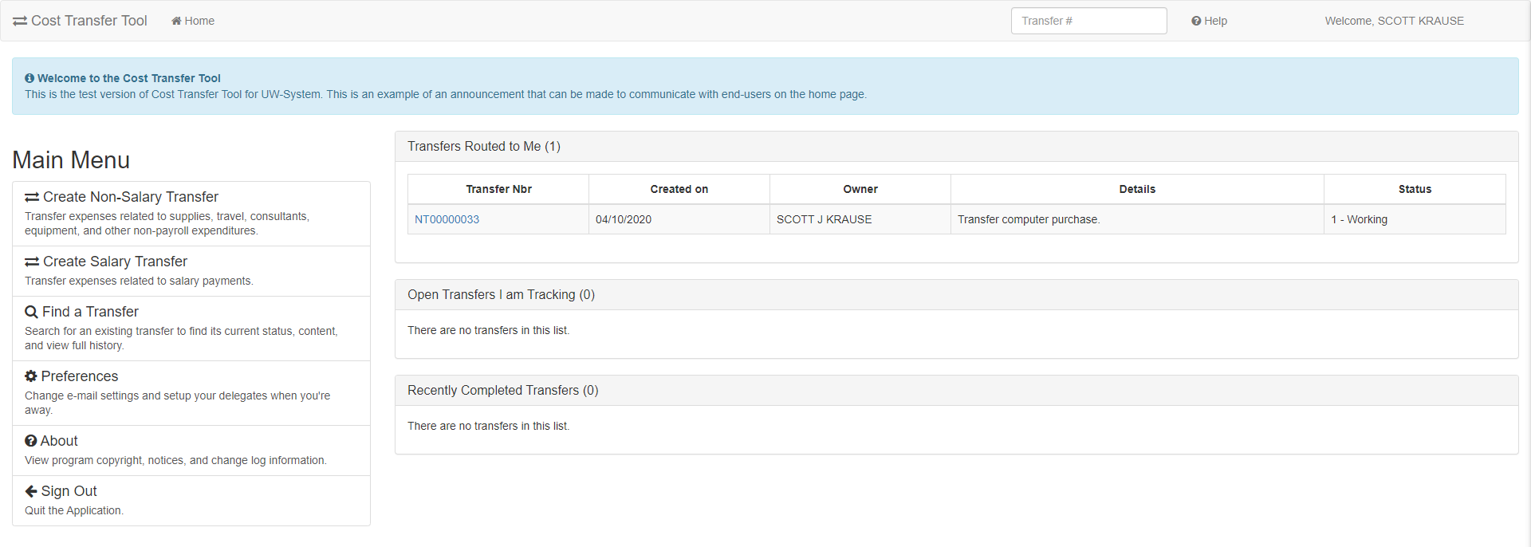

This is the main screen or landing page from which the preparer begins – think of this as the main menu or “Home” screen.

Work list Headers that apply to you will appear.

Work List Headers:
- Transfers Routed to Me: You are the owner of this transfer record (edit rights)
- Open Transfers I am Tracking: Unapproved transfers in process that you prepared
- Recently Completed Transfers: Posted transfers that you prepared

Tips:

Clicking on work list header expands and collapses transfer record list Click on the Find a Transfer link to view transfers based on specific criteria

Creating a New Non-Salary Cost Transfer

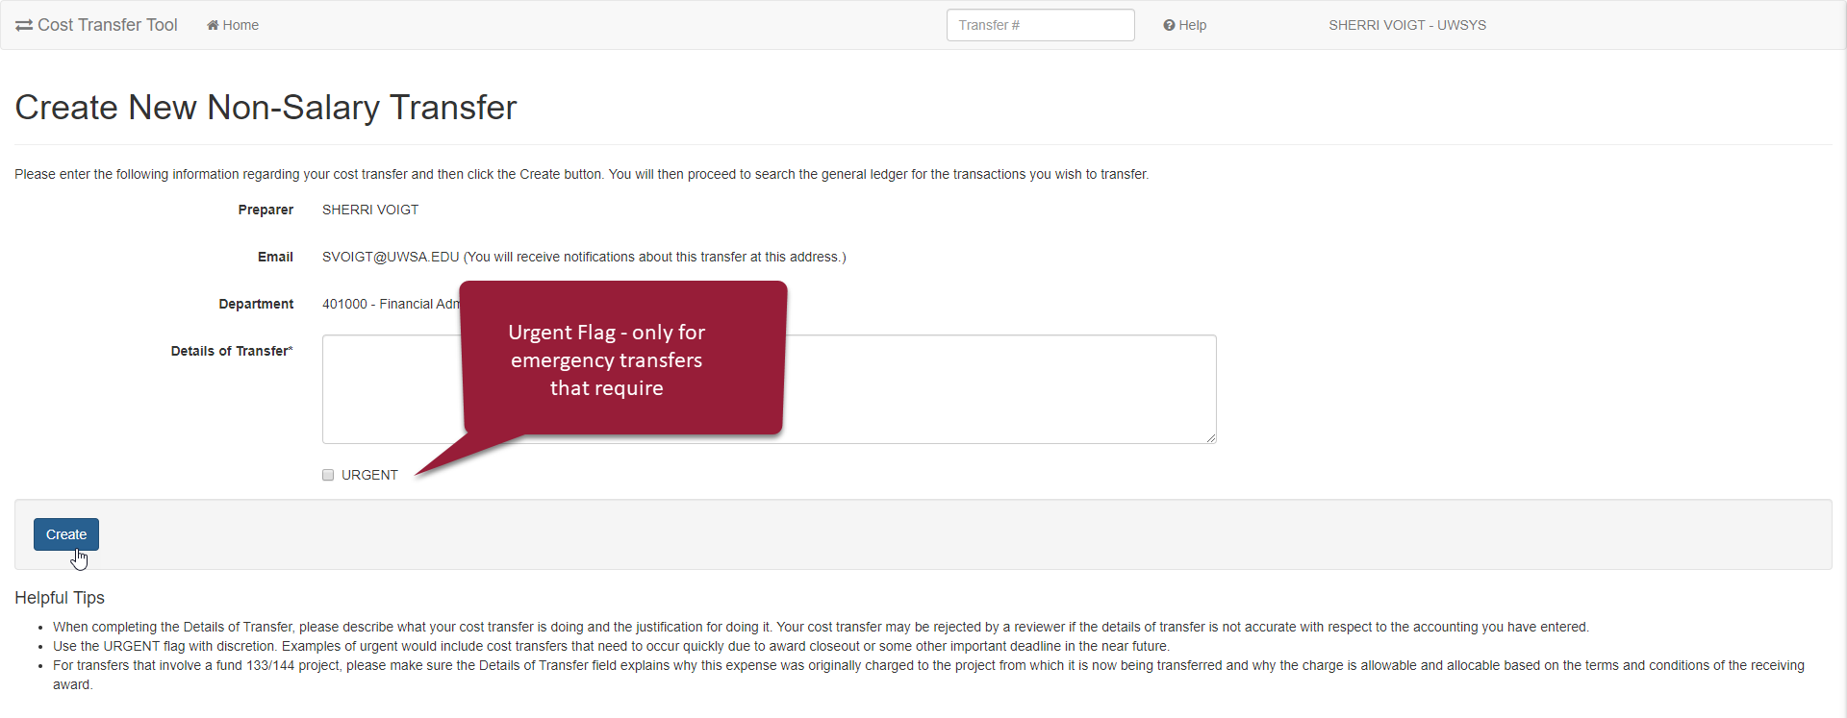

Under the main menu in your dashboard click “Create New Non-Salary Cost Transfer”

ALWAYS – Enter Details of the NSCT – Details should be clear and concise so reviewers/approvers can understand the reason for the transfer. This can be edited during later stages of preparation. Urgent flag is used to indicate an important deadline (e.g. award closeout or fiscal year-end) and will move the transfer to the beginning of the queue for the approvers or “routed to” persons.

After entering Details of Transfer click on button to “Create”.

Add a Transfer Set

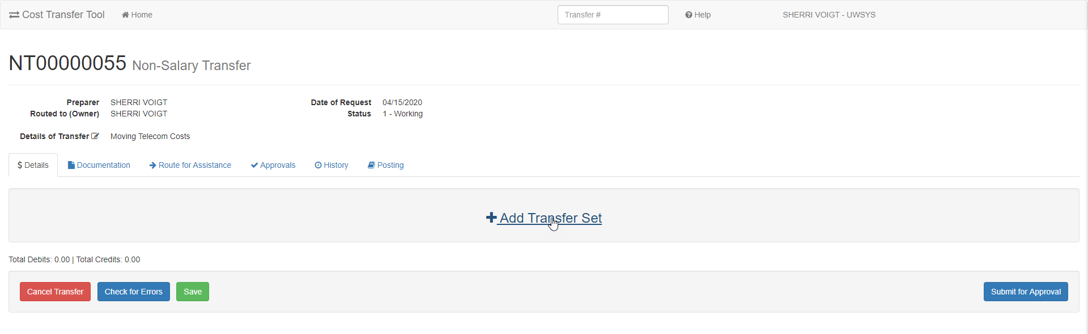

Clicking on “Create” takes you to the Non-Salary Cost Transfer screen in which new transfer sets are created.

In order to start the transfer, you must click on “Add a Transfer Set.” By adding a transfer set, you search for a specific transaction from WISER.
Transfers cannot be created without a corresponding transaction in WISER. This guarantees that the “From” side of the transfer is correct.

Search Screen for “From” Transactions

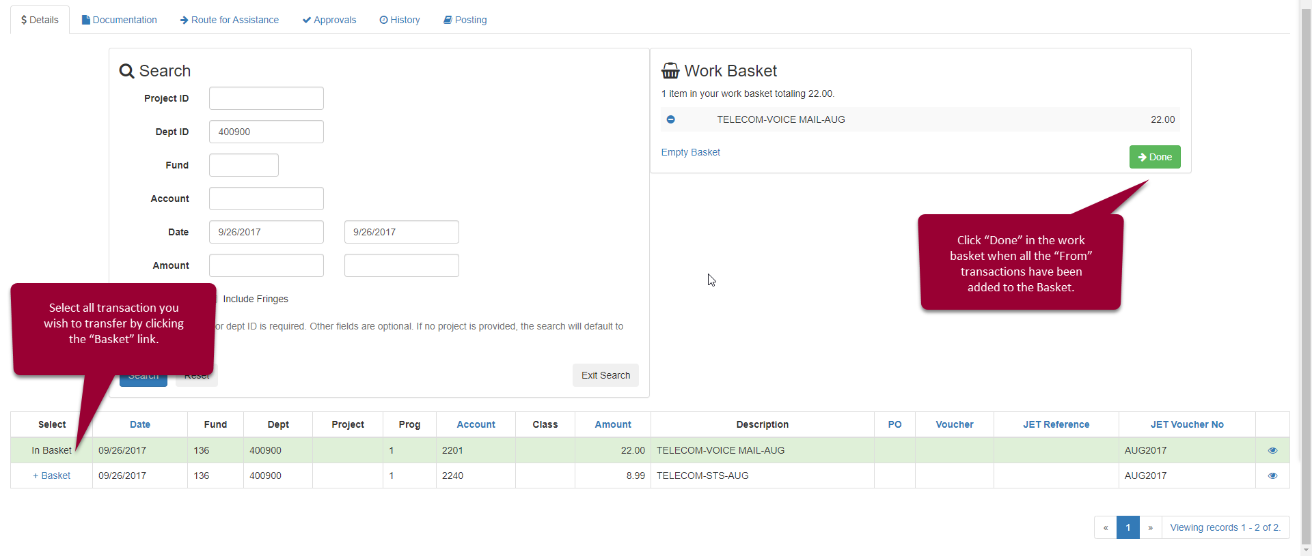
Use the Search options to quickly find the “From” transaction. A known date or amount should be entered in the first box and second is left blank. Entering more specific data (Project ID or Dept ID and Fund) will return a smaller list of possible transactions to select for transfer

This icon will display additional WISER fields:
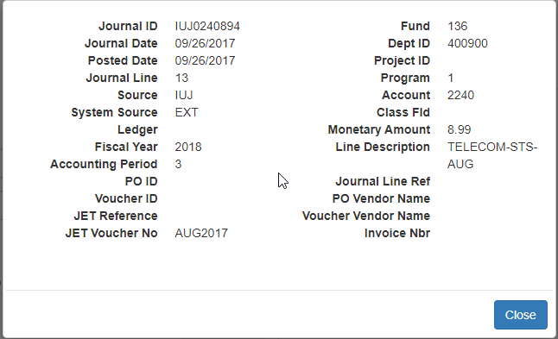

Entering the “To” Side of the Cost Transfer Transaction

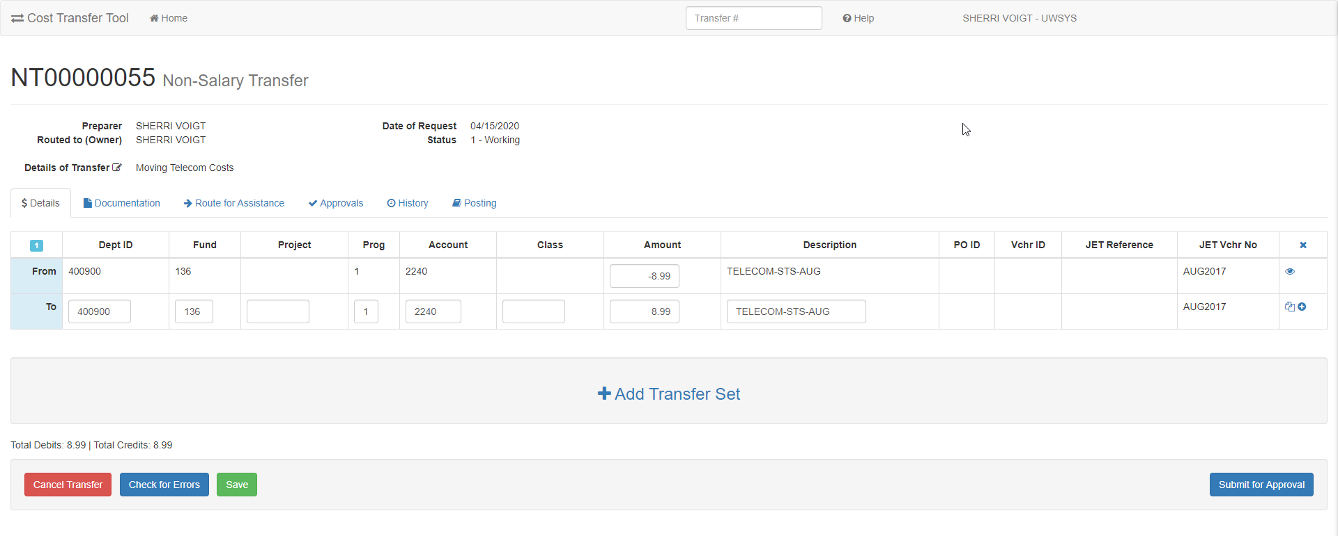

Screen Icon key:
View more detail – additional fields from WISER are displayed
Copy to all – Dept ID, Fund, Project copied to all “to” lines
Split – add a “to” line to split the “from” transaction

Important: Decreasing the “From” amount is considered a “partial” transfer. The Cost Transfer Tool does not allow the “from” to be changed to an amount that is more than the original expense.

As you enter the “Transfer To” account information you may find it useful to use the “Copy to all” function to update all the “To” lines.

Checking for Errors

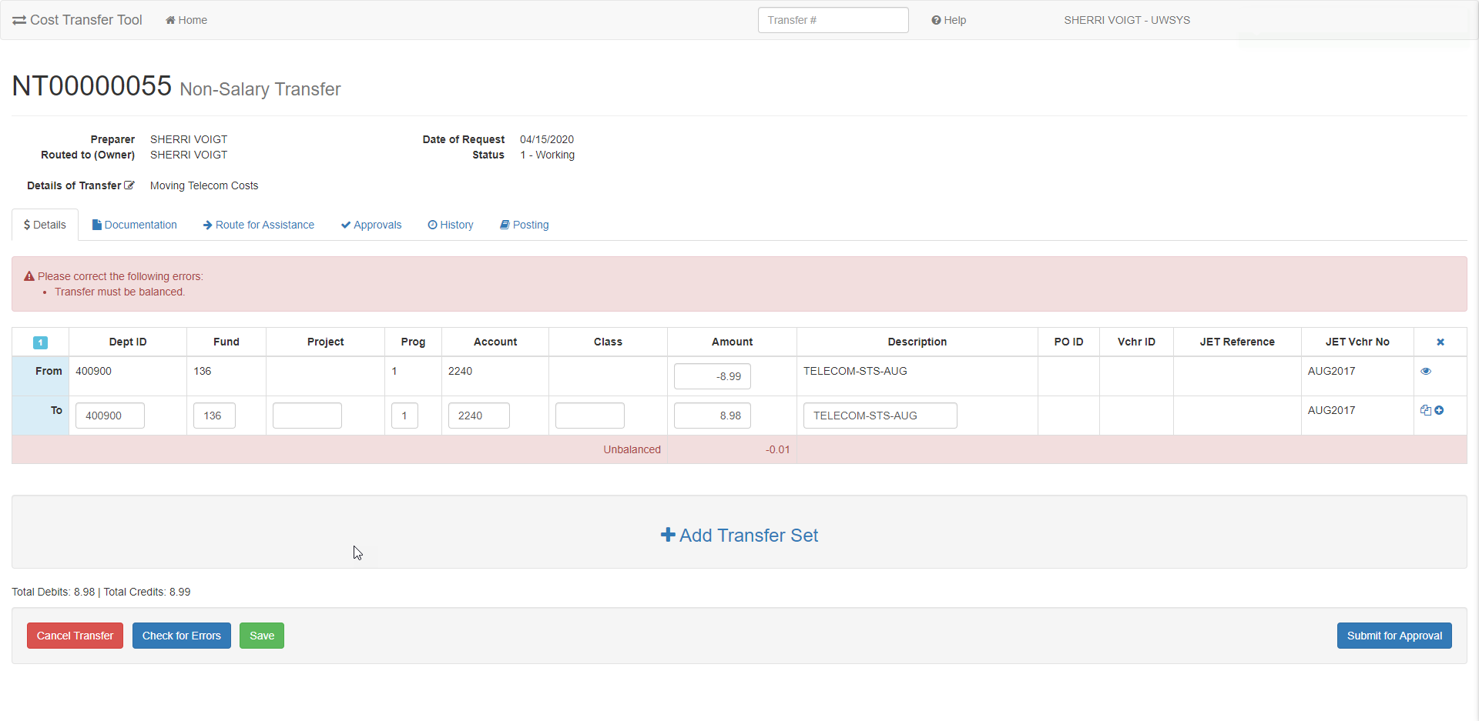

Checking for Errors validates the funding string and enforces balanced accounting. This will also calculate the applicability of the >90-day rule (i.e., >90 days have passed from the end of the month that the original expense posted) and require that a justification be completed.

Documentation Tab

The documentation tab allows you to attach documents or add comments to support the proposed transfer. To add, click the Add Attachments or Add Comments button.
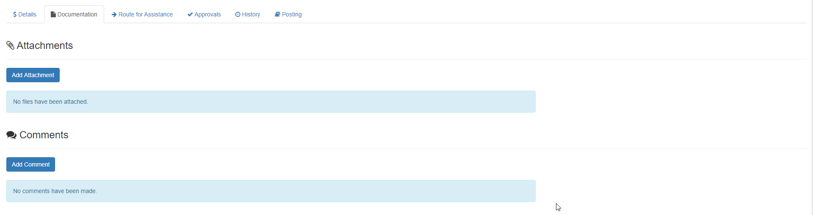

- **Note on what situations require attachments. **
- Comments that are included with routing and rejections are stored here.
- WISER documentation is NOT REQUIRED, as the tool validates the authenticity of the “From.”

Documentation/Comments/Justification for Transfers 90 Days After the Original Transaction

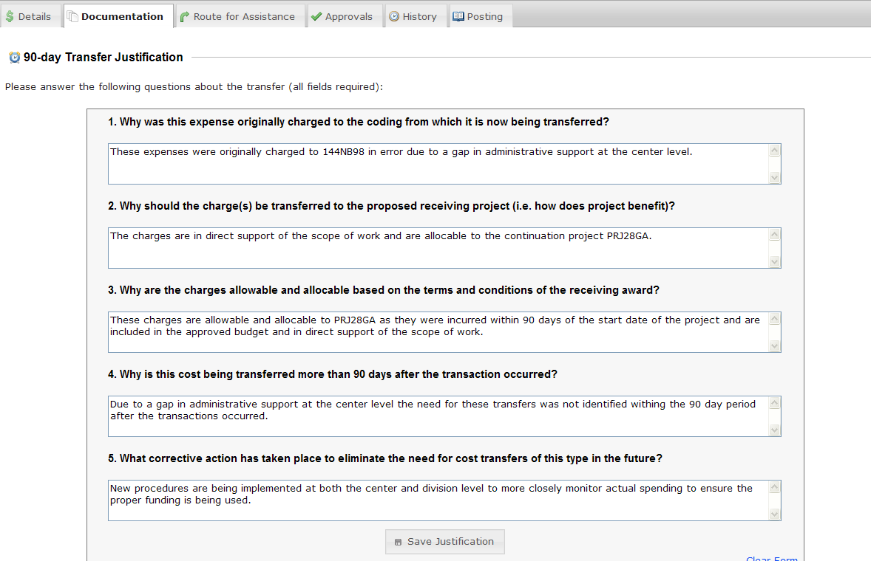
If the transfer is over 90 days, the preparer will be automatically required to fill out the justification, which can then be viewed in the documentation tab. Attachments can also be seen here, if any are attached to the transfer. Comments are also stored in this tab.

Definition - 90 Day period is technically 90 days from the end of the month a transaction is posted.

NSCT Routing, Edit Rights and Ownership
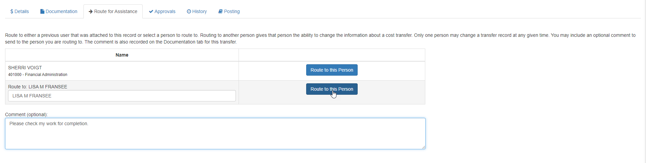
IMPORTANT! Routing is NOT used to collect signatures. “Routing” is intended for assistance or
to accommodate a department’s internal workflow. Routing a record gives permission to edit the cost transfer record. The person you route to will be notified by email of this action and the transfer record will appear in their worklist.

Example of notification e-mails automatically sent out when a transfer is routed to another user. NOTE: a direct link to the transfer record within the Cost Transfer Workflow Tool is embedded in the email.

*** Original intended recipients: Barnie Rubble ***
A cost transfer has been routed to you.
You may edit transfer ST00000032 by following this link: https://www.ct.sfs.services.wisc.edu/sct/32
Transfer Synopsis:
Created by: Fred Flinstone
Created on: 3/31/2020
Details of transfer: Test.

Submitting NSCT Requests for Approval

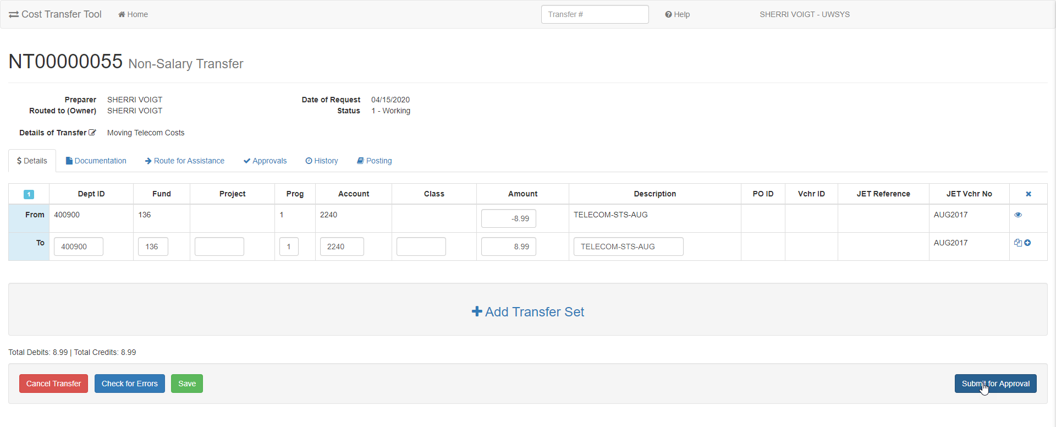

The owner of the record “routed to” can submit for approvals. Once submitted, the status changes to “2-Waiting for Approvals”. The tool determines the required signatures and automatically notifies the approvers.

NOTE: Routing a transfer to another user transfers ownership. The preparer no longer has edits rights when a transfer is routed to another user or submitted for approval.

History of the Transfer

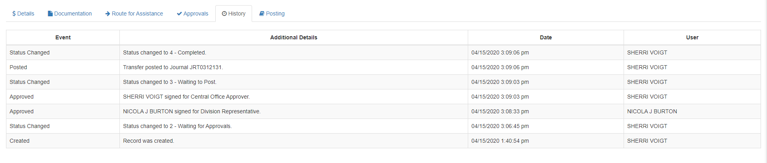

Major events are captured and retained in the history tab.

Salary Cost Transfers for Preparers

Salary Cost Transfers uses the same functionality as Non-Salary Transfers with some differences due to the difference in process. Use the link to “Create a new Salary Cost Transfer”

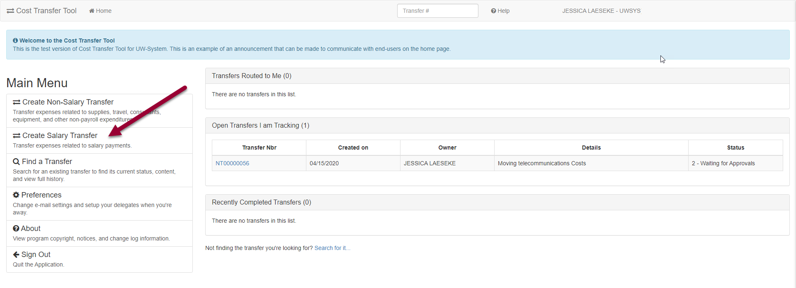

Create SCT Detail

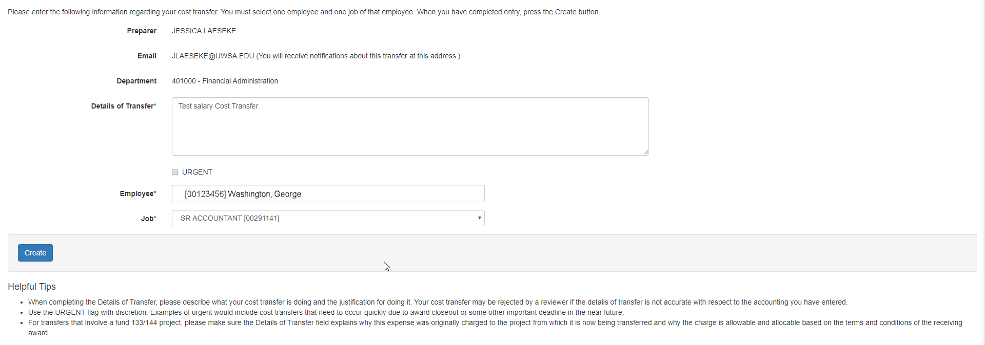

ALWAYS – Enter Details of the SCT – Details should be clear and concise so reviewers/approvers can understand the reason for the transfer. This can be edited during later stages of preparation. Urgent flag is used to indicate an important deadline (e.g. award closeout or fiscal year-end) and will move the transfer to the beginning of the queue for the approvers or “routed to” persons.

For Salary Cost Transfers, there must be an employee selected at the transfer details panel. Enter employee last name to get a drop-down list of employees. For common last names, leave a space and continue typing the first name to narrow the list. After selecting the correct employee and job, click the “Create” button.

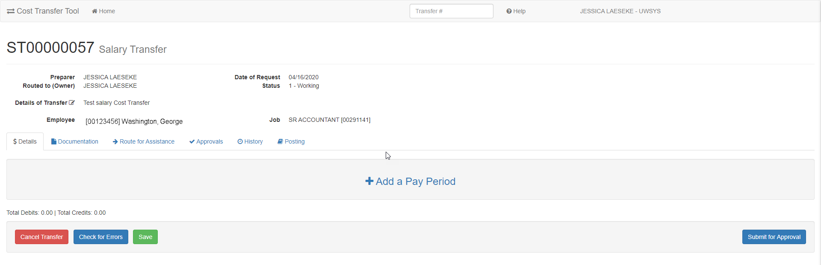
Clicking on “Create” takes you to the Salary Cost Transfer details screen.

A unique transfer number is assigned, and other basic information is displayed in the heading.
In order to start the transfer, you must click on “Add a pay period” to search for specific payroll transactions in WISER. This guarantees that the “From” side of the transfer is correct.

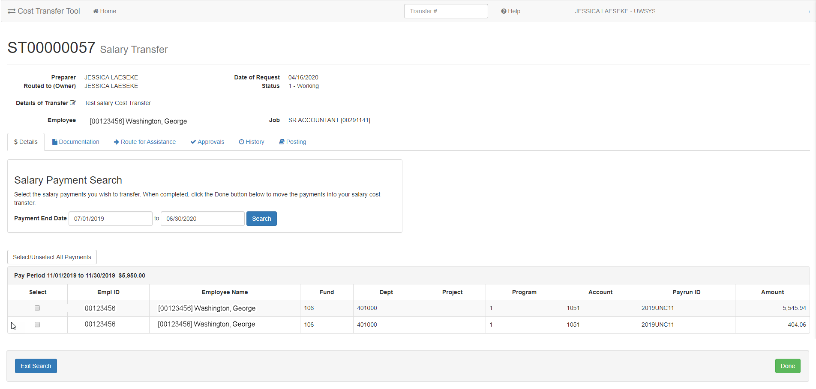

The default for the search criteria is the current fiscal year. Change the date parameters to get older payment results.

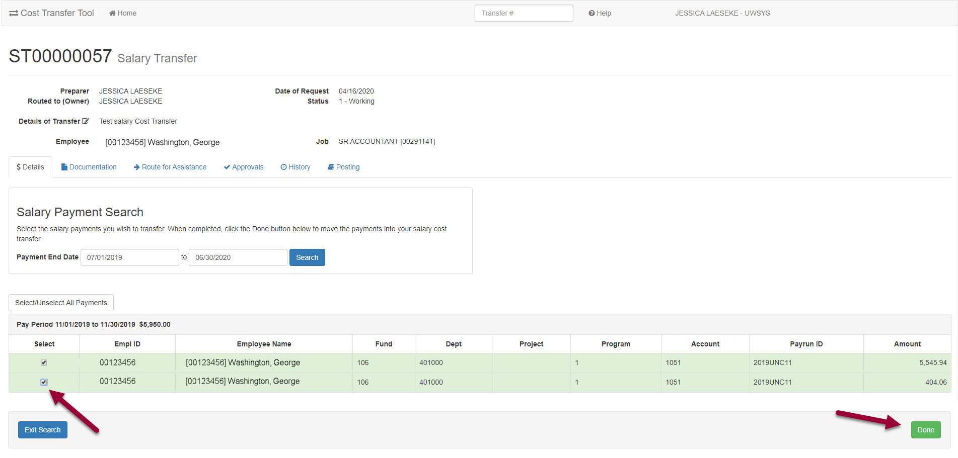
Select the pay periods that require transfer by using the “Select” box. Use the “select all salary payment” option if transferring the entire search result.

This creates a set of transfers.

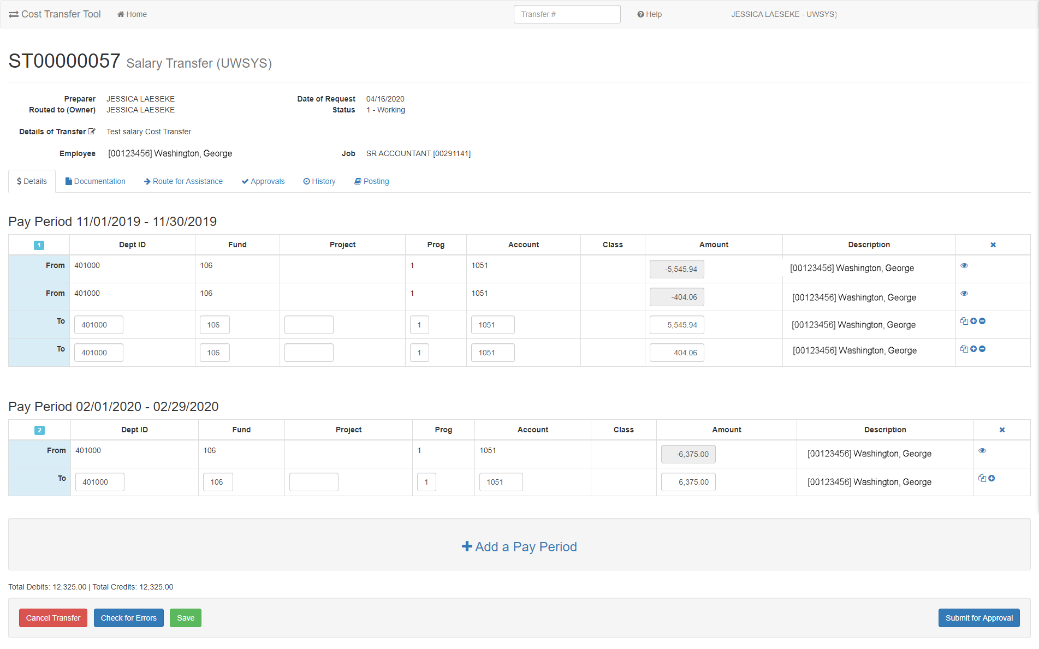

Transfer sets ready to enter new coding in the “To” line.

Screen Icon key:
View more detail – additional fields from WISER are displayed
Copy to all – Dept ID, Fund, Project copied to all “to” lines
Split – add a “to” line to split the “from” transaction
Delete Line – Remove the line. This is only available when you have multiple “To” lines for one pay period.

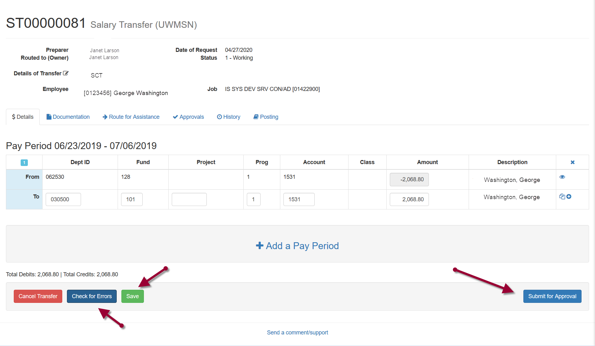When coding has been entered, save, check for errors and then Submit for Approval.

Submit for approval will automatically validate the accounting string. In this case there are errors.
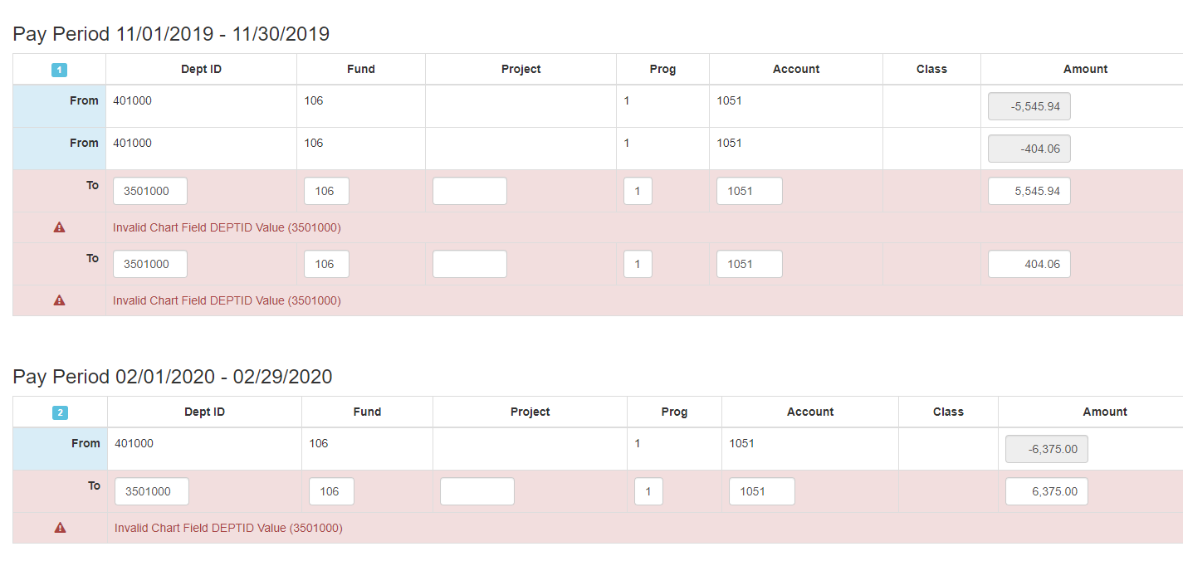
Oops! Error message when coding does not pass edits. Clicking Submit automatically validates funding.

Update Funding and then “Check for Errors”.
Submit for approval again. Message is displayed that Transfer has been Successfully Submitted for Approval.

SCT Approvals

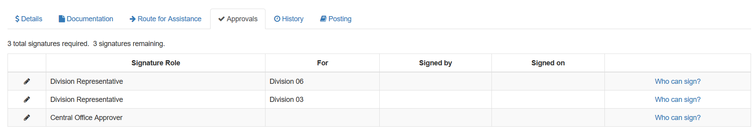

Clicking on approvals tab will display approvals required for the transfer to go through.

Clicking on the “Who can sign?” link returns a list of approvers for this Transfer.

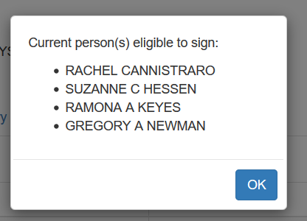

SCT History

History Tab displays actions for this transfer.

Instructions for Division Approvers

Approvers’ Dashboard View
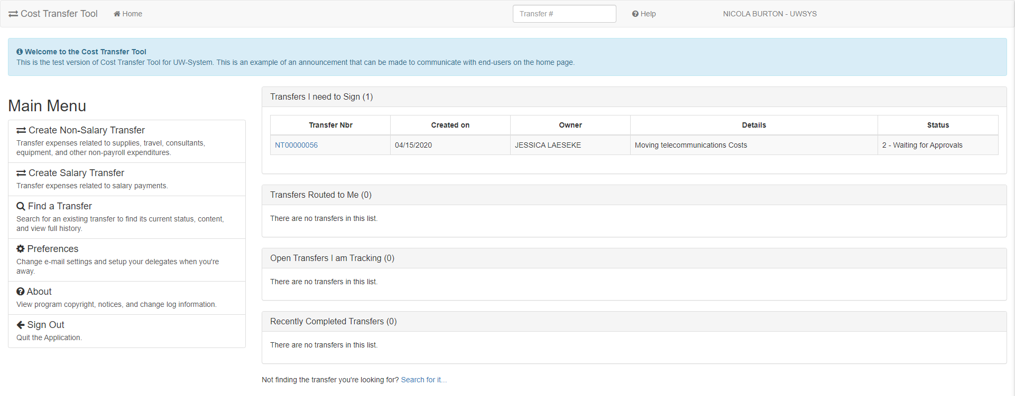

This is the main screen or landing page from which Approvers begin – think of this as the main menu Work List Headers:
“Transfers I need to Sign”- transfers requiring your review and approval (displays if there are pending items)
“Transfers Routed To Me”- transfers needing your review and comments and would normally be routed back to the preparer
“Open Transfers I am Tracking”- transfers in the approval process
“Recently Completed Transfers”- only displays transfers that you have prepared

Tip: Clicking on work list header expands and collapses transfer record list
Tip: Non-Salary Cost transfers will always start with “NT”. Salary Cost transfers always start with “ST”.

Delegating Signature Authority

This allows you to designate another user to approve transfers on your behalf. This can be a co-worker who will cover for you during an absence or a permanent delegation. Click on the link to delegate and to set up other preferences, such as turn-off e-mail notifications.
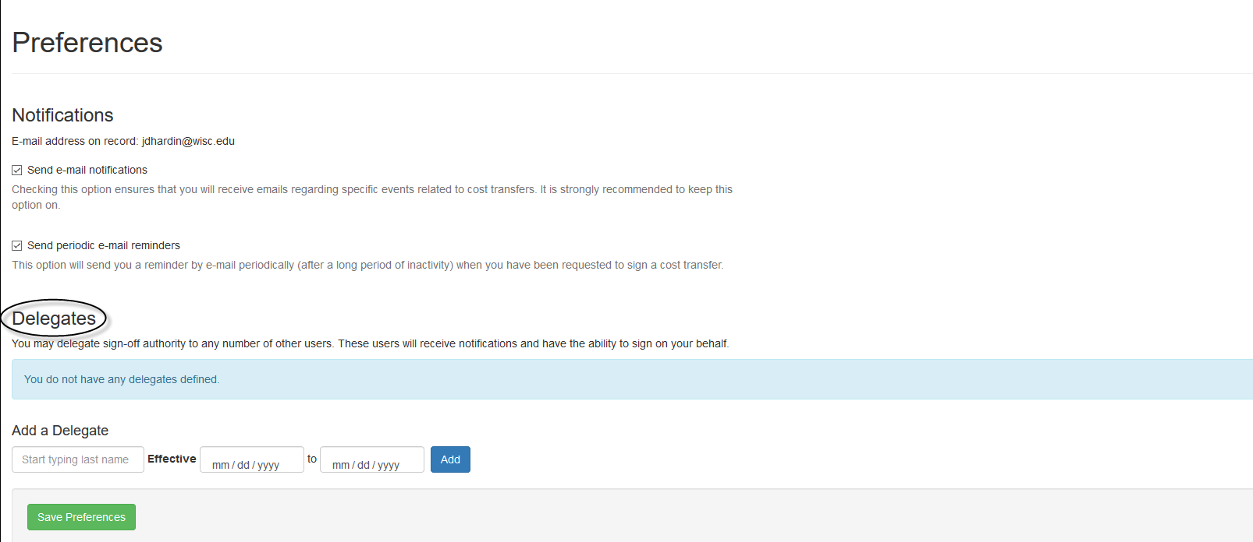

Notifications:
Emails notify approver when a new cost transfer requires their electronic signature
If desired, stop e-mails by unselecting the “Send email notifications” box
Additional option to receive reminders when a transfer has not been worked on

Delegation:
Delegation allows assigning delegates with the authority to electronically sign cost transfers on their behalf
- Allows storage of multiple delegates to accommodate various business processes (e.g. one delegate for non-salary and one for salary)

Email Notification to Approvers That a Cost Transfer Requires Approval

*** Original intended recipients: ERIC J STEBERL, SHERRI VOIGT ***
Transfer NT00000063 requires approval from you for Sponsored Programs Accountant.
Please review the transfer by following this link: https://www.ct.sfs.services.wisc.edu/nsct/63
Transfer Synopsis:
Created by: JACQUELINE MILSKI
Created on: 4/20/2020
Details of transfer:
Test AAG7746 - ability for UWMSN PI to approve UWSYS transfer

Notification emails include a direct link to the Dashboard view within the Cost Transfer Workflow Tool

Viewing the Details of a Cost Transfer

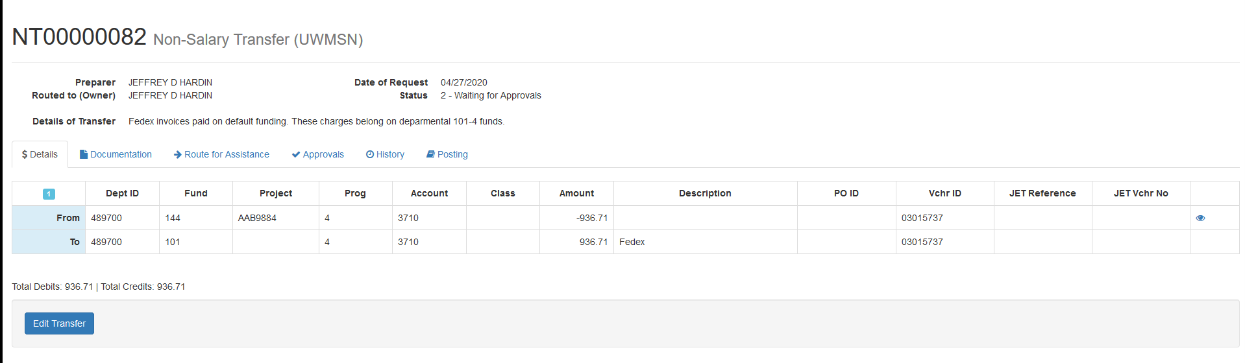

Clicking on the link from the work list brings the user to the Details tab showing the “From” and “To” coding

This is where an approver can review the Details of Transfer and the accuracy of the account coding associated with the cost transfer

Accounting / Coding of Non-Salary Cost Transfers

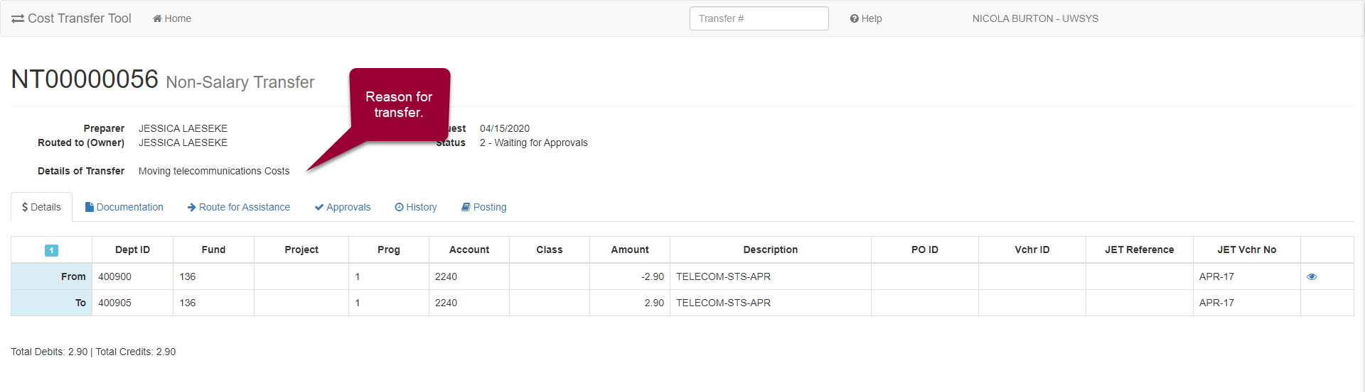

- Fields are locked once the record enters the “2-Waiting for Approvals” status Detail tab will have the “From” and “To” transactions

Justification for Transfers 90 Days After Date of Original Transaction

If the transfer is over 90 days from the end of the month that the transaction posted, the preparer will be automatically required to fill out the justification, which can then be viewed in the documentation tab. Attachments can also be seen here, if any are attached to the transfer.

Collecting Signatures
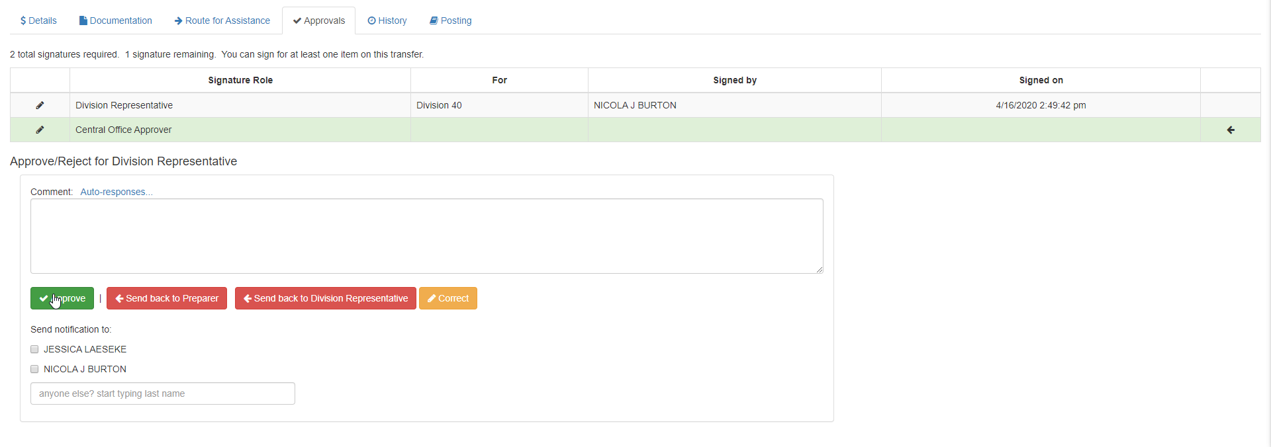

The Cost Transfer Workflow tool automatically determines required approvals:
Identifies the user and highlights (shading and green arrow) which projects require the user’s approval
Approvals are in the following tiers and are captured sequentially: PI, Division, Sponsored Program Office. Within those tiers, signatures can be collected in parallel (Multiple Division Reps can sign simultaneously for cross divisional transfers).
Clicking “approve” captures your signature on the transfer record and no further action is required. The form collects signatures using automated system generated notifications.

If the accounting or justification needs more work, click “Send back to Preparer” or enter correction mode by clicking “Correct” to make the correction(s) yourself. If you send back the transfer, it is a good practice to include a comment telling the Preparer the revisions you are asking them to perform. Alternatively, clicking “Correct” reverts the record to the “1-Working” status, which allows editing. After the correction is made, click the “Submit for Approvals” and then “Approve” in the approval tab.

Email Notification: Sponsored Program Office Send-Back to Division

BONITA MARIE WIKENHEISER rejected transfer NT00000065 for Principal Investigator.
View this transfer's details at: https://www.ct.sfs.services.wisc.edu/nsct/62
Transfer Synopsis:
Created by: JACQUELINE MILSKI
Created on: 4/21/2020
Details of transfer:
Test search fields

A Division Approver would receive an email if Sponsored Program Office is unable to approve a cost transfer and “sends back” ownership of the cost transfer to the Division Approver.

The Cost Transfer Workflow Tool routes the record back to the Division to grant edit rights for corrections. Divisions can perform the requested fix or can route the record to preparer; see next screen shot for more details.

Manage Approvers

Each Division will authorize a group of expert users that will have Division Approval Authority. From the main page, click on Manage Approvers.
- This authority will also include security to assign the entire division, a range of departments or a single department for a Preparer
- The Preparer does not need to know who the Division Approver is; this is built into the tool.

IMPORTANT - When the transfer set is contained within one Division – only one approver is required by the system. Please consider your Division’s business practices and use “Routing” to alert other approvers of transfers, when necessary.

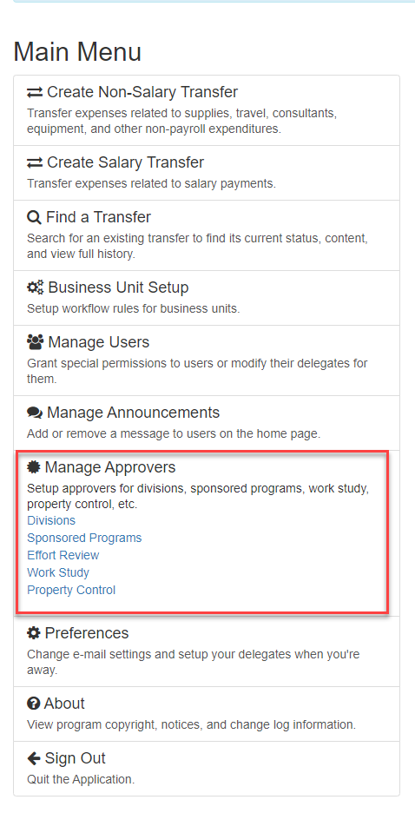

Manage Division Access

The Cost Transfer Workflow Tool enables Divisions to establish their internal workflow by adding Divisional Representatives and / or by setting Department ID Ranges.

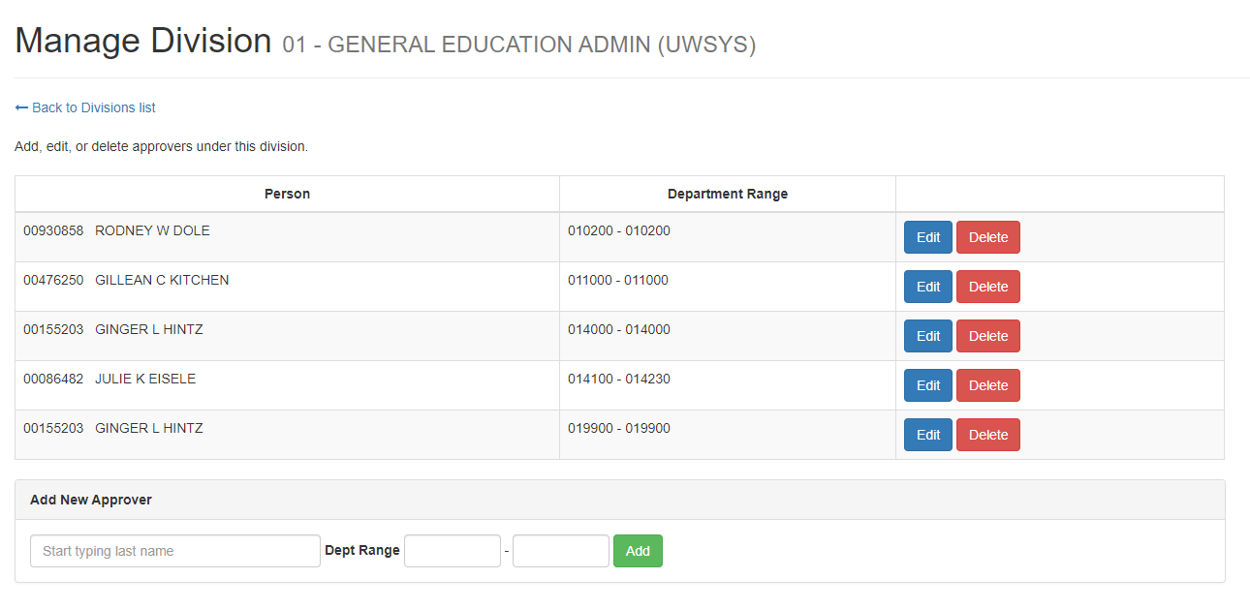

Manage Sponsored Programs Approvers

The cost transfer administrator at the institution maintains the billing specialists for sponsored programs.

Note: Supervisor is currently not used for BUs other than Madison for suspense funding.

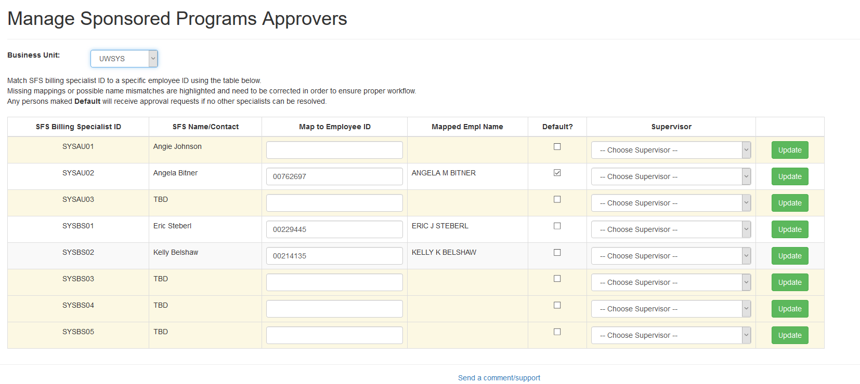

Manage Effort Approvers

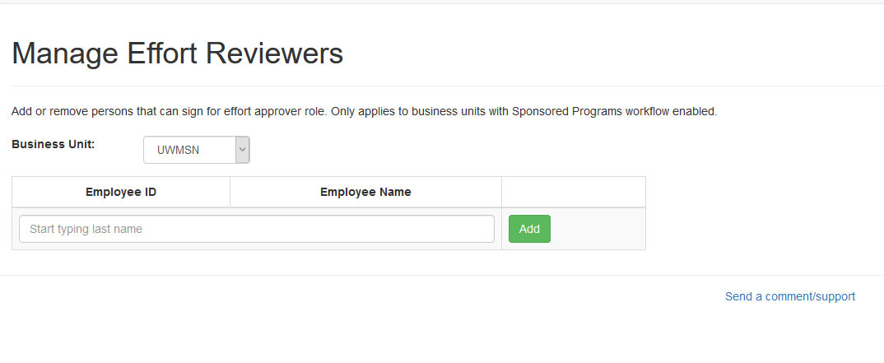

Manage Work Study Approvers
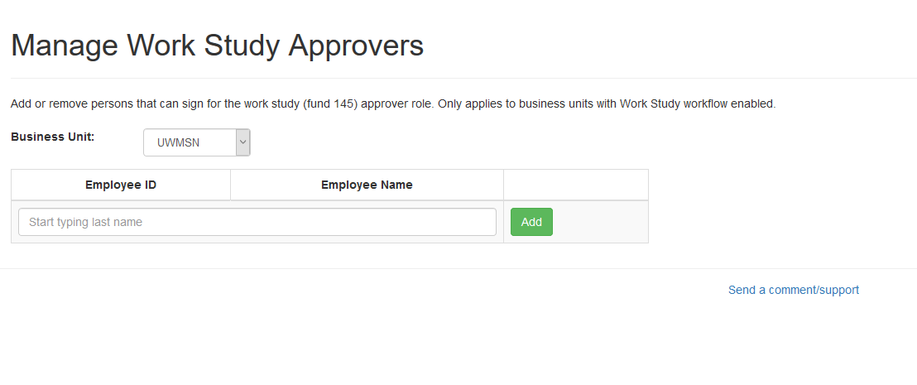

Manage Property Control Approvers

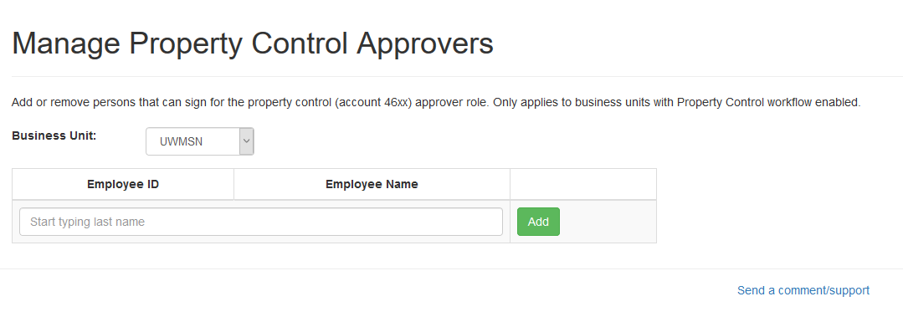

General Information

Sign In

Logging In and Getting Started:

- Go to https://ct.sfs.services.wisc.edu
- If you have authenticated to another UW Service, you will be taken directly to the Cost Transfer Tool
- Otherwise, you need to sign in through WIFED (Federated Login Screen) which is the authentication mechanism for the Cost Transfer Tool. Choose your institution and enter your credentials.

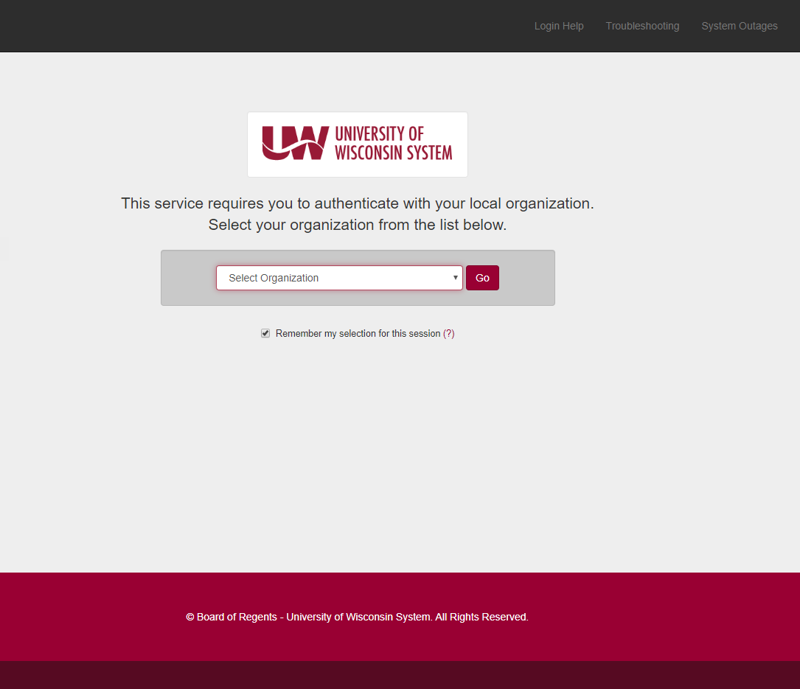

Sign Out

At the bottom of the main menu, select sign out to exit the application.

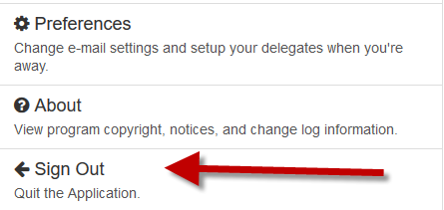

Home

The Home link in the upper left corner returns to the Dashboard.

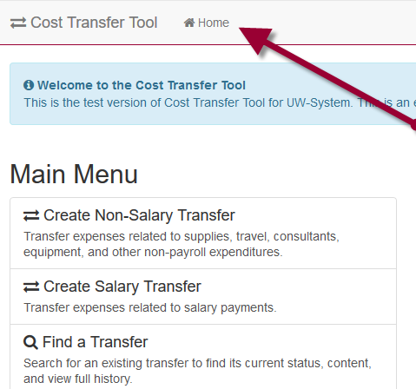

Searching for Transfers

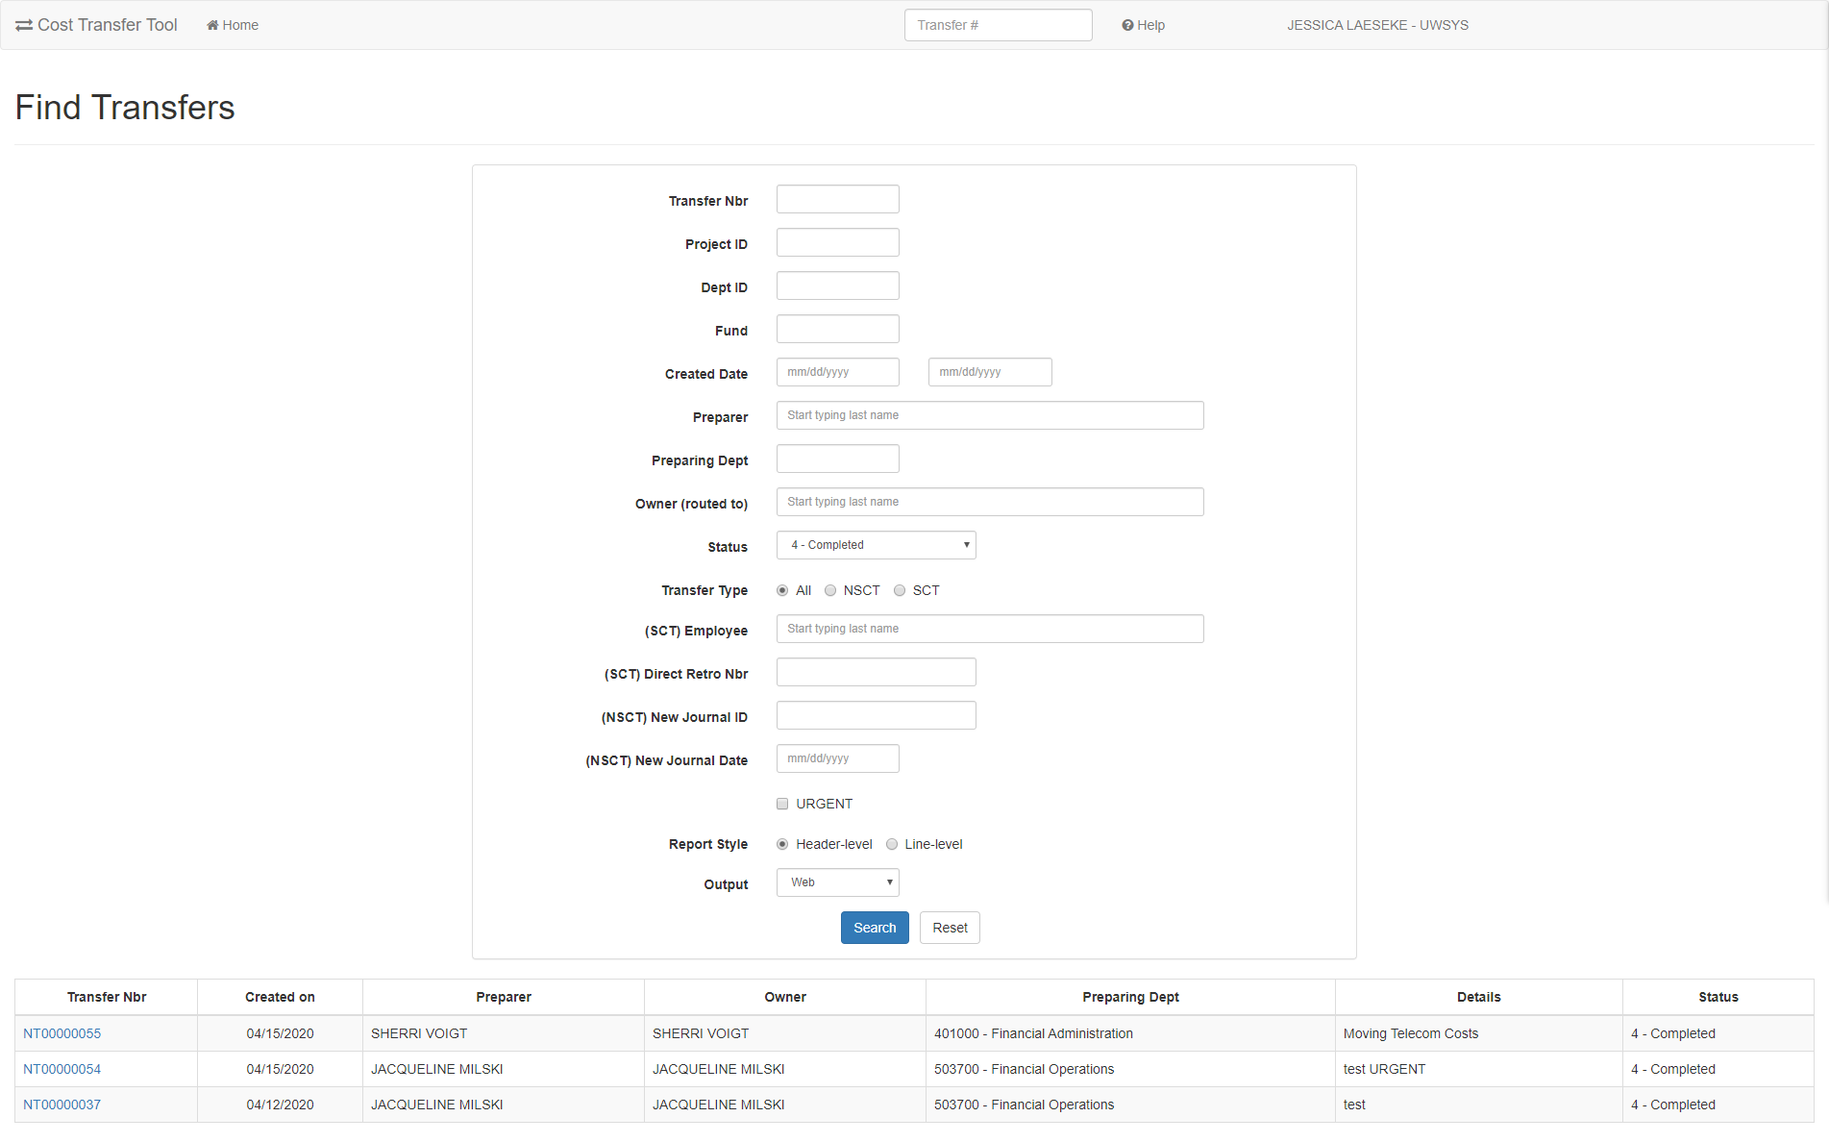

On the “Find a Transfer Screen” users:
- Can search for completed transfers
- Can search for transfers in process
- Can use multiple filtering options (e.g. Project ID)
- Can search for any transfer, not just transfers prepared by you, and view comments, documents, preparer, approvers, etc.…

** Eliminates the need to print a copy for your file **

Send A Comment/Support

Use this mechanism to report issues, ask questions, seek support. For institution specific cost transfer questions or training issues, please contact your local institution support.

If you do not have a mailto: set up on your computer, you will be asked to create an account. Do not do this. It is not recommended to use the default mail app. Instead, set the default email application.

Set the default email app (mail.exe) in Windows settings. This only needs to be done once.

- Go to start settings
- Choose Apps
- Select default programs
- Change default email app from “mail” to desired email application (e.g. Outlook, Office 365)

An alternative is to right click on the “Send a Comment/Support” link and chose copy email address. Paste this email address into the web browser address field.

See https://kb.wisc.edu/helpdesk/170 for more information on different Windows versions.

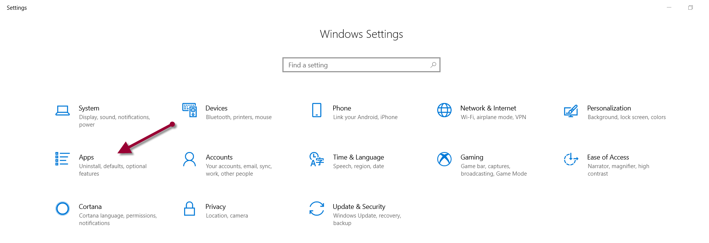

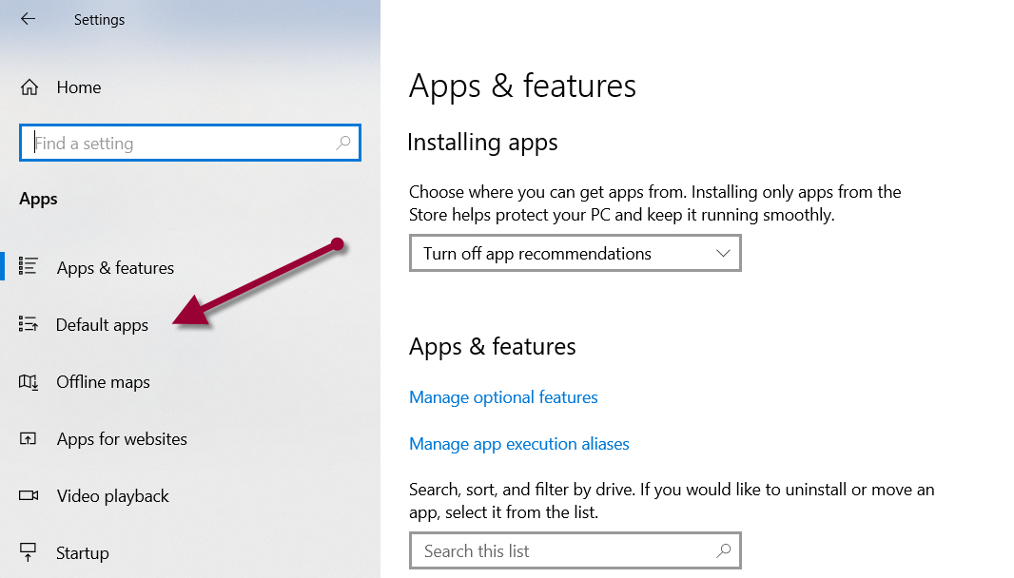

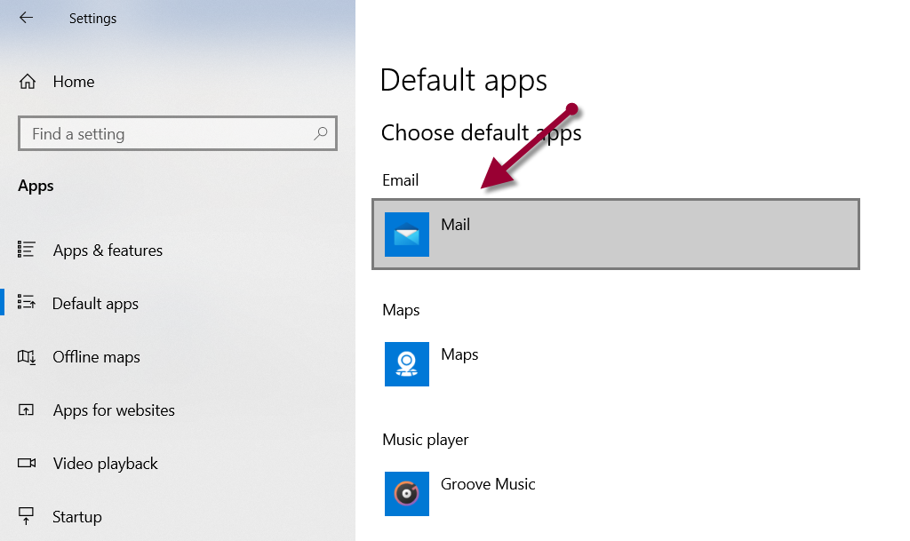

Select Mail application.

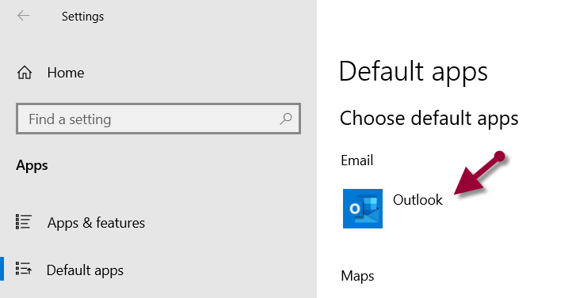

Preferences

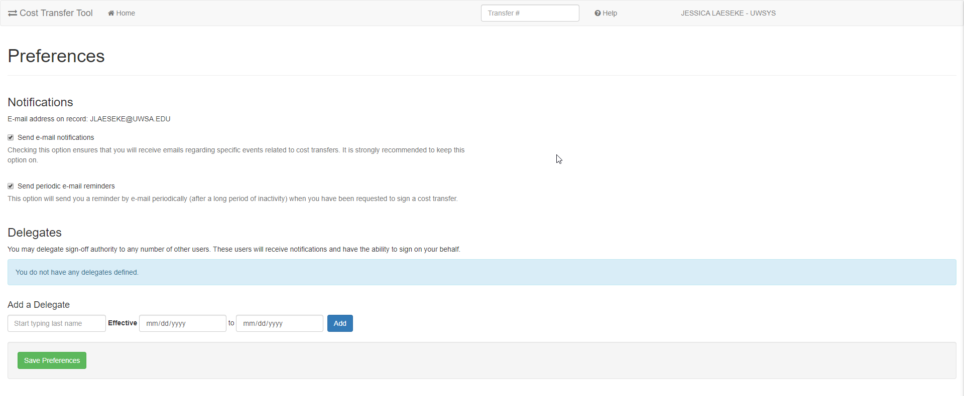
Managing Email Notifications: Users can turn off the e-mail notification if they are frequently logged into the Cost Transfer Tool. Preparers can also delegate sign-off authority for anticipated absences.

To Delegate – begin typing in the last name of the delegate. For common names use a space and then first letters of first name.

You must push the “Save Preferences” button to save any changes made to this page.

About

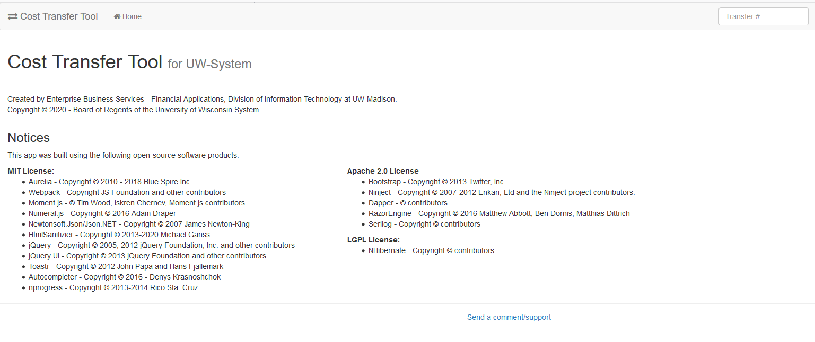

Session Expired

If the session expires, simply click on the link to refresh the application.

WISER Journal

Transfer number will be available in WISER in Journal Description. You can search for the transfer by using this number.

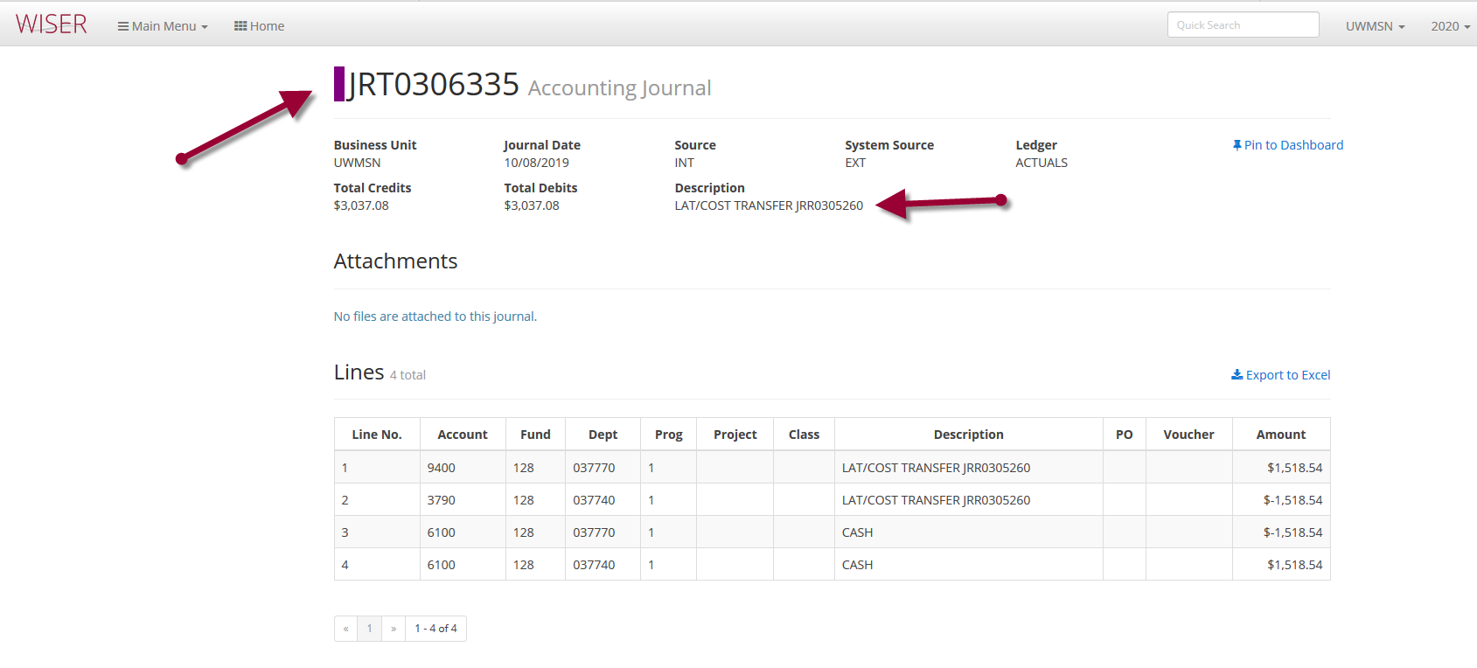

Starting with WISER

A transfer can be initiated right from WISER. The transaction is loaded into Cost Transfer Tool and basic metadata is requested. This allows users to initiate a transfer when they see the need in the system where they are examining data from rather than looking in WISER and then repeating the same search in Cost Transfer Tool. This works for SCT and NSCTs.

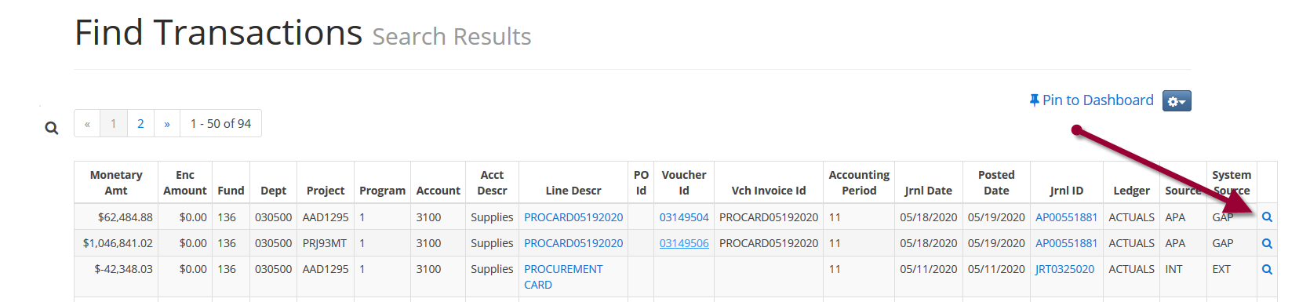

Find a transaction and then click on the magnifier to the right.

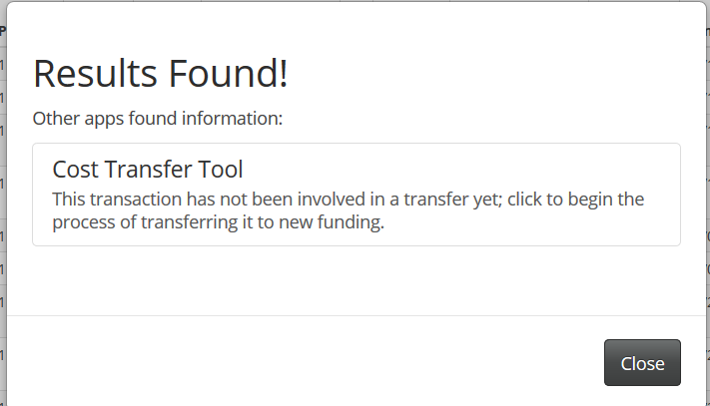

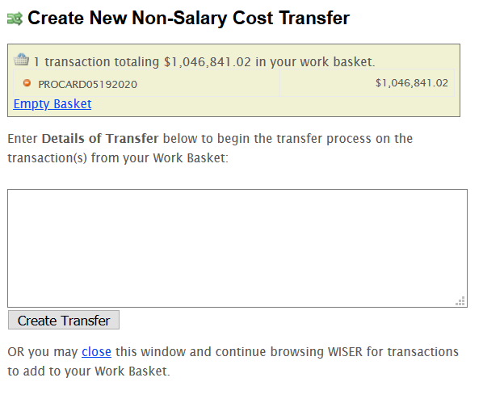

See descriptions in the application for each entry.

This is the initial setup needed for a BU in order for other setup to be available. The use of cost transfer tool for a specific institution is set here. For example, Madison uses another version of SCT and would not typically turned on in production in this version.

Approval methods for division, sponsored programs, and final approval must be selected.
- Division Approval Method determines the division approvers
  - Internal Table – uses the internal lookup table that maps department ranges to divisions (see Manage Divisions within CTT to set up internal table)
  - SFS Expense Managers – uses the business unit's SFS e-Reimbursement workflow configuration.
  - SFS Dept Table - uses the business unit's SFS DEPT_TBL manager configuration.
- Sponsored Program Approval Method for sponsored programs
  - Billing Specialists – provide the billing specialist search pattern (e.g. SYS%,RSP%)
    - For institutions using Grants Suite
  - Grants Accountants
    - For institutions not using Grants Suite

Salary Cost Transfer Tool Application Administration Manual (UWSA SFS Only)

BU Setup

Cost Transfer Tool administrators at each institution (BU Administrators) will manage their staff access once UWSAProblemsolvers sets up their users. This access includes the ability for sponsored programs effort, work study and property control approvers.

In addition to approvals, the use of suspense accounts is managed in this setup.

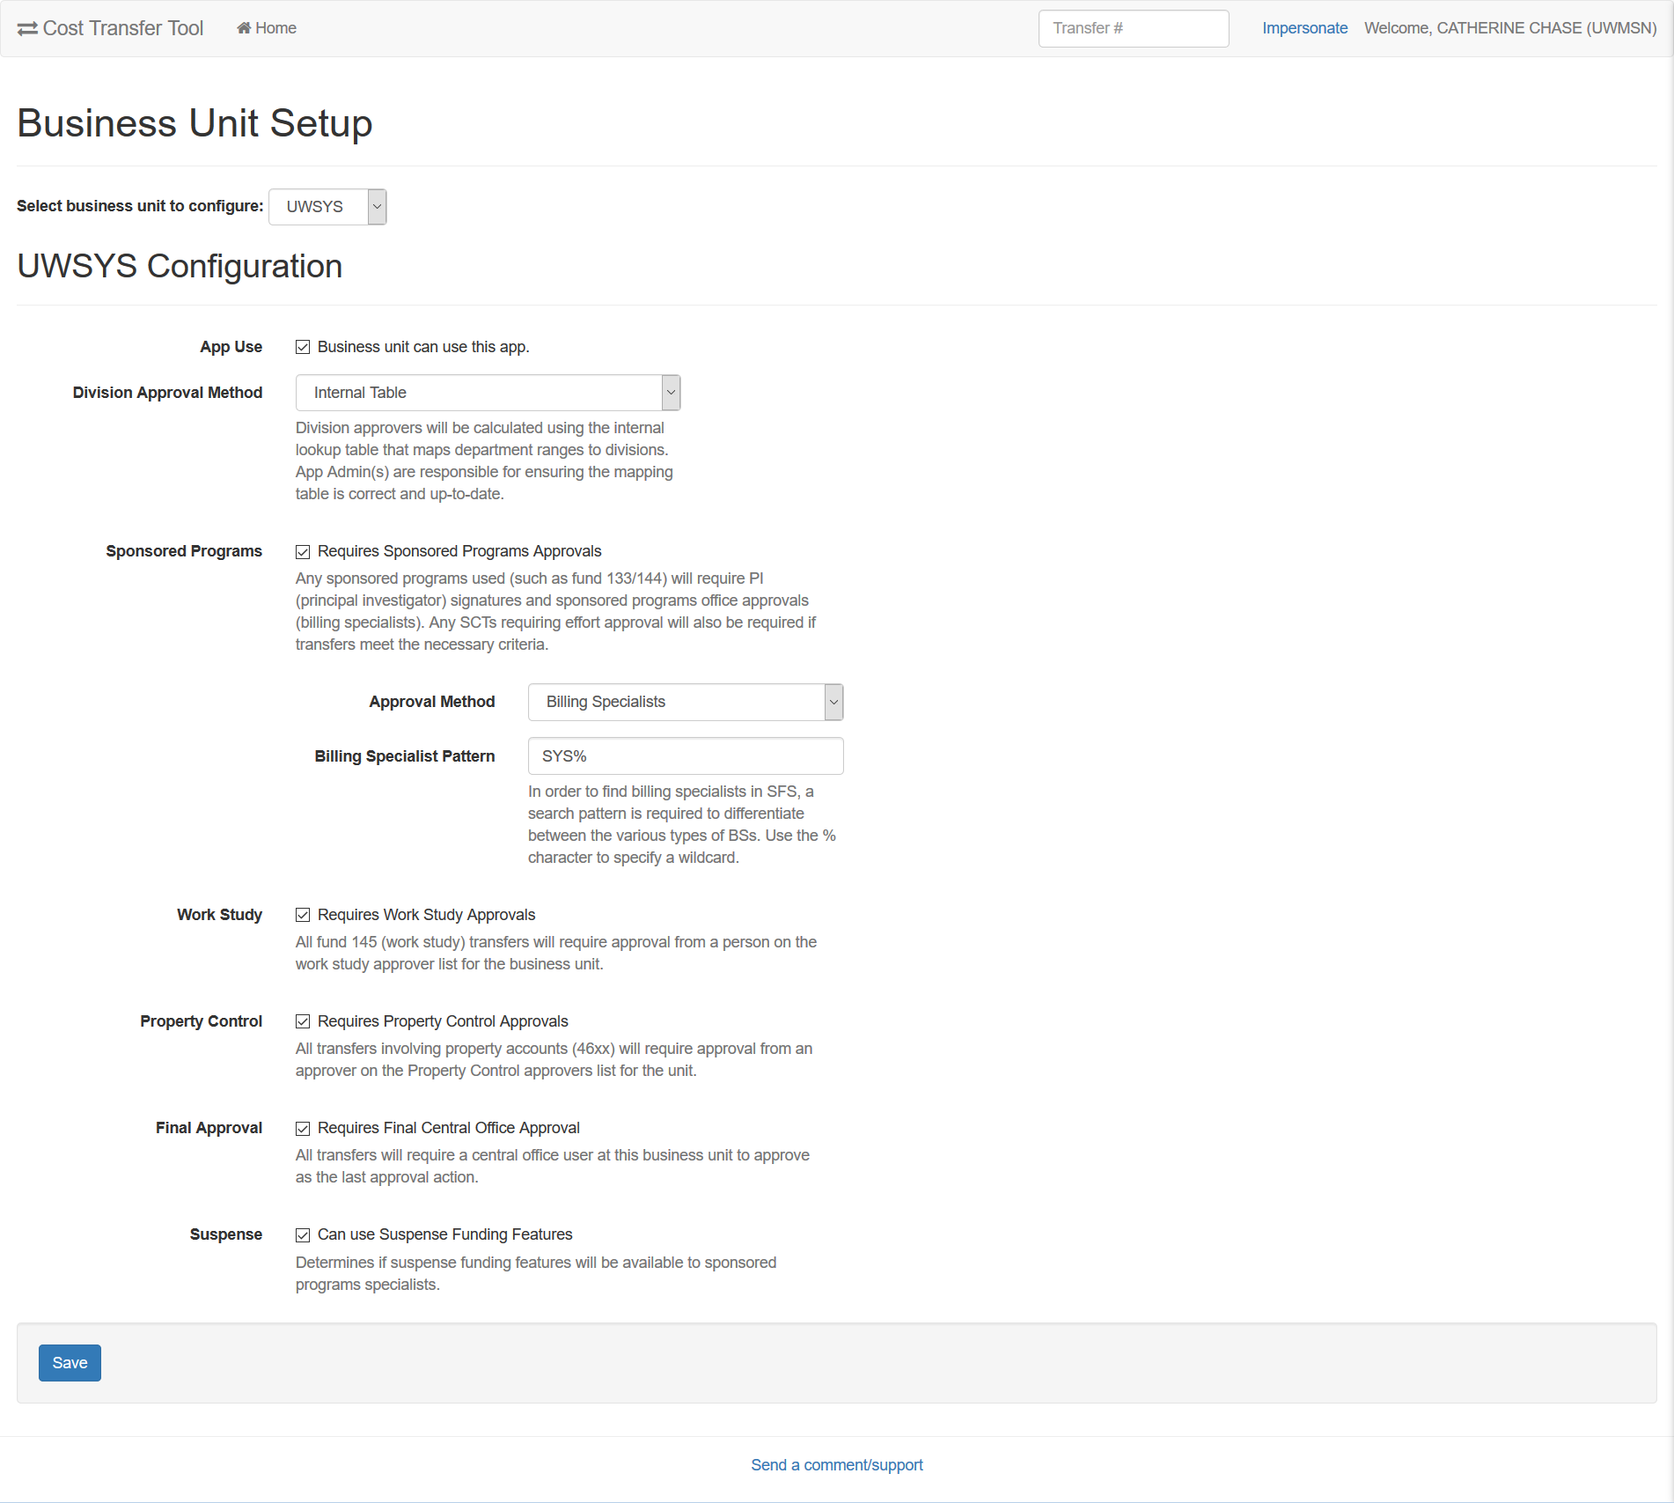

Manage Users

The Cost Transfer Tool Administrators (UWSAProblemsolvers) manages the users. These individuals are setup as Site Administrators. Site Administrators have special privileges and also all access granted to other roles.

Each institution will have one or more individuals who will have BU Central office final division approval.

Institutions must provide a list of staff than can perform actual SCT, including closing and reopening SCT for editing.

Each institution will have one or more individuals who are responsible for managing approvals – Division and Sponsored Programs.

Each institution must provide an initial list of users and their responsibilities. The administrator at the specific institution must provide updates via email to UWSAProblemsolvers in order to maintain user access (additions/deletions of users).

Individual users can manage their own delegated authority. The CTT Administrator for SFS can also update delegated authority if the person is not available.

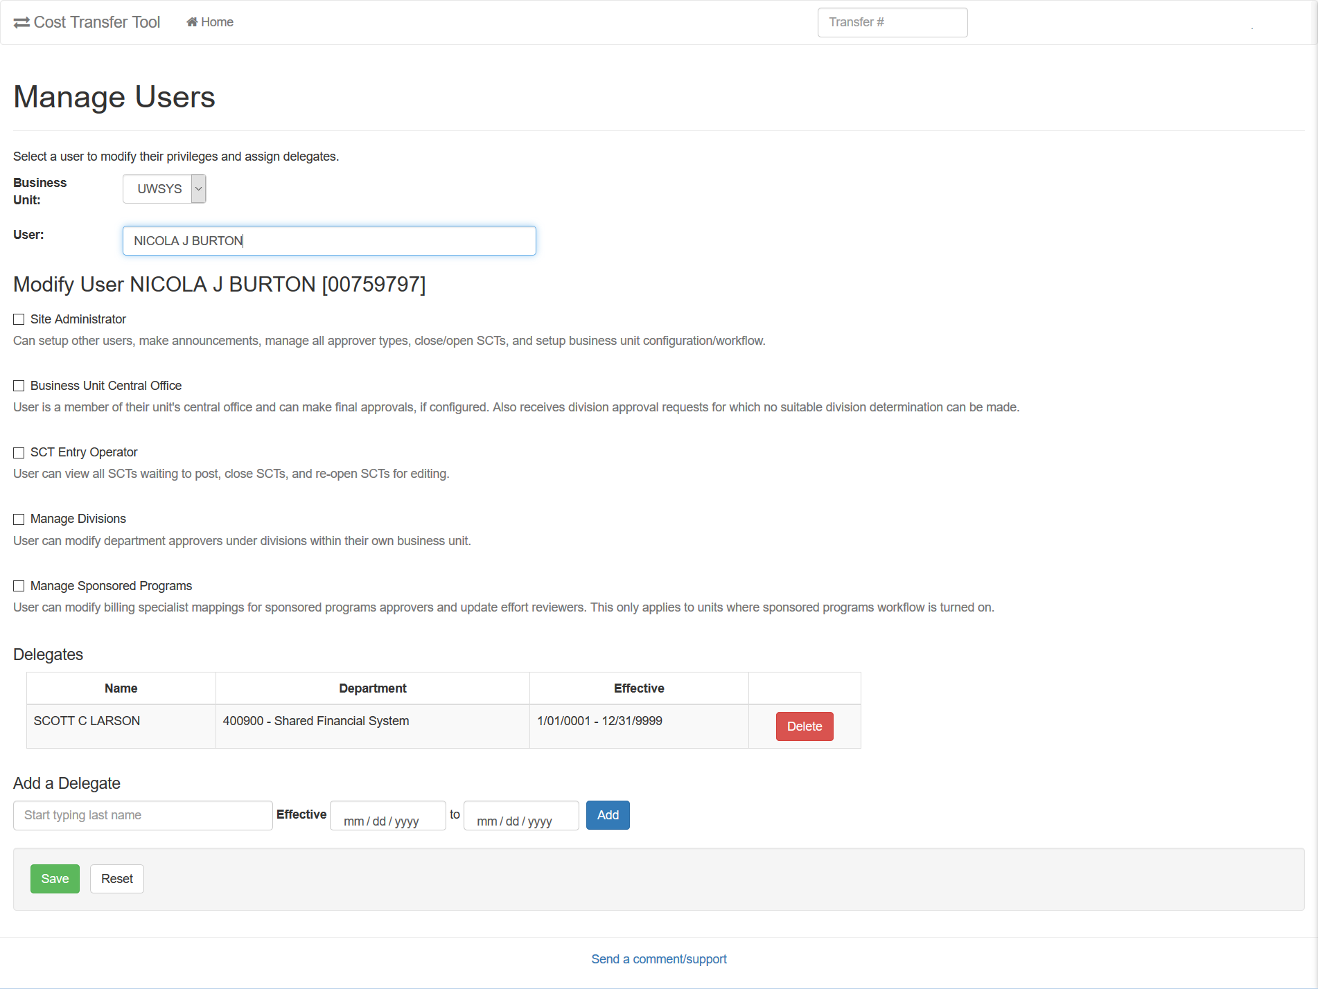

Manage Announcements

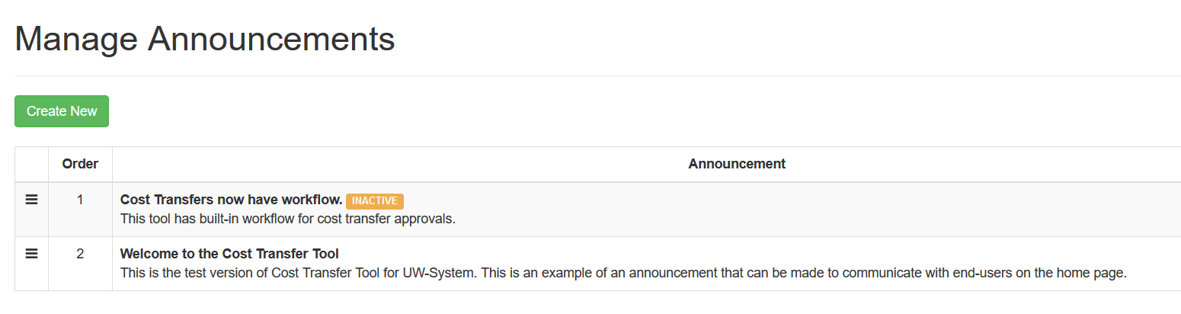
Application Administrators (UWSAProblemsolvers) can provide application announcements as needed. These announcements are system-wide and not intended for individual institutions.

An example of use is an upcoming outage.

