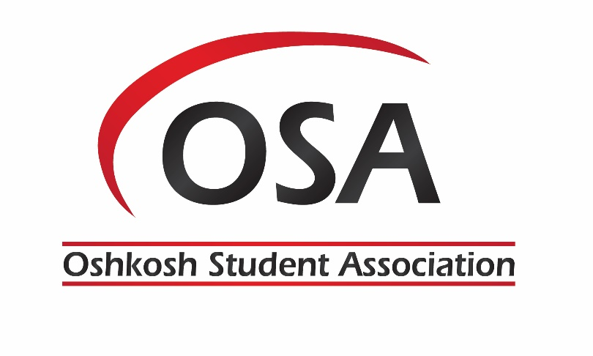

OSA Student Government Retreat
August 24-26, 2018
Heidel House Resort & Spa – 643 Illinois Ave, Green Lake, WI

Executive Board
- Time:
  - August 24 – 26, 2018

- Place
  - Heidel House https://www.heidelhouse.com/wisconsin-meetings/conference-center
- Agenda
  - Friday, August 24, 2018
    - 1:30 PM - Departure from campus
    - 2:15 PM – Check In
    - 2:30 PM - Unpacking
    - 3:30 – 4:30 PM - Guided Public Yacht Tour of Green Lake
    - 5:00 – 7:00 PM - Dinner
    - 7:00 – 10:00 PM - Team Building in one of the guest rooms overlooking Green Lake (team bonding and Jenga, Salt and Pepper, and Company Coat of Arms) – see below for team builder instructions
    - 10:00 PM – rest for Saturday’s agenda

  - Saturday, August 25, 2018
    - 8:00 AM – Breakfast
    - 9:00 AM – Welcome by Chancellor Leavitt
    - 9:15 AM to 10:15 AM– Attorney, Jill M. Kastner, OSA Alumni – Keynote speaker - Leadership
    - 10:15 to 10:30 AM – break
    - 10:30 AM to 11:30 AM – Inclusive Excellence – Who and when to contact individuals for issues on campus and in the community. (Dr. Tony Laing)
    - 11:30 AM to 12:00 PM – Exec discuss Goals for 2018-19 (Roni Howard, OSA President)
    - 12:00 to 1:00 PM – Lunch (OSA Senators, Directors, Ambassadors, Fond du Lac, and Fox Valley Exec join)
    - 1:00 to 2:00 PM – Leadership: Who We Are and What We Do. The session will/can include discussions/activities about Strengths and How We Use Them, Values Based Decision Making, and Group Dynamics: Conflict is Inevitable (Carmen Hetzel, Program Adviser for Emerging Program & Special Events ) – Students will complete Strength Quest during lunch break
    - 2:00 to 3:30 PM – Tank Commander – Team Builder
    - 3:30 to 3:45 PM - Break
    - 3:45 – 4:30 PM – Shared Governance, Parliamentary Procedure and Robert’s Rules – (Goodwill Obieze, OSA VP, Ellen Dodge, OSA Speaker, and OSA Chief of Staff )
    - 4:30 – 4:45 PM – Break
    - 4:45 – 6:00 PM – Principals of Operation – Organization Chart of UW System and UW Oshkosh (Dr. Cheryl Green)
      - Organization Chart of OSA and each exec describe duties (Roni Howard, OSA President lead, and each exec follow)
    - 6:30 – 7:00 PM – Dinner (on their own for dinner)
    - 7:00 – 10:00 PM – Bonfire reserved – make S’mores and Pudgie Pies

  - Sunday, August 26, 2018
    - 9:30 AM – pack and breakfast
    - 10:15 AM - Farewell team builder (Office Trivia) and group picture
    - 11:00 AM – Depart for Campus
Group Activity

Office Trivia
For: Team Bonding
What You'll Need: 20-25 trivia questions about your workplace
Instructions: Looking for a quick and easy team building activity? Come up with a series of questions specific to your workplace and test your team's knowledge. "What color are the kitchen tiles?" "How many people are in the IT department?" "How many windows are there in the entire office?" "What brand are the computer monitors?" "What month of the year is most common for birthdays among our employees?" This is a quick team building activity that tests how observant your team is.
.
Salt and Pepper
For: Communication Skills
What You'll Need: Tape, a pen, a small piece of paper for each employee and a list of well-known pairs (think peanut butter and jelly, Mario and Luigi, or salt and pepper).
Instructions: Write one half of each pair on the sheets of paper (Mario on one piece, Luigi on another, and so on). Tape one paper to each person's back, then have everyone mingle and try to figure out the word on their back. The rule: they can only ask each other yes or no questions. Once they figure out their word, they need to find the other half of their pair. When they find each other, have them sit down and find three things they have in common while the rest of the team continues.

For: Team Bonding
What You'll Need: Paper, pens, markers
Instructions: Have teams create your company coat of arms. In the first space, draw something that represents a recent achievement. In the second space, draw something that reflects your company values. In the third space, draw something that represents where you see the company going in the future. Post the finished coat of arms in your office.

Jenga
For: Team Bonding & Ice Breaking
What You'll Need: A Jenga set (preferably with large blocks)
Instructions: This one is a fun team building icebreaker for work that will get your team to test their limits. Write a question on the surface of each block. Make them answer it.

