How to Register for Courses Using College Scheduler

- Go to https://uwosh.edu/

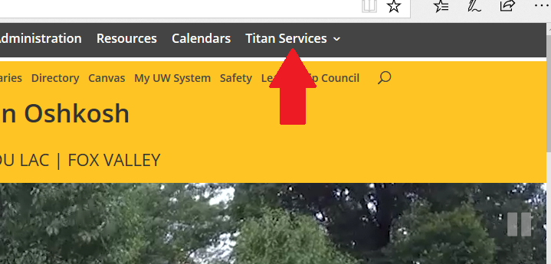
- Hover over “Titan Services”

- Select “Titan Web”

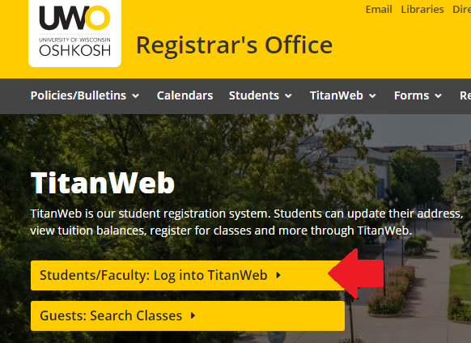
- Click “Titan Web Student Information”

- Log into your Titan Web account

- Click “College Scheduler”
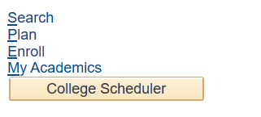
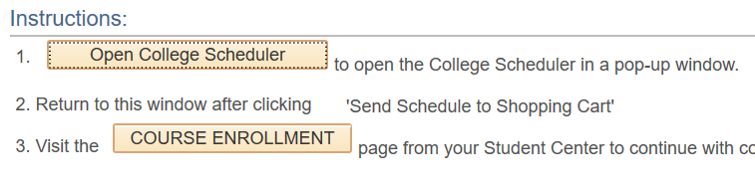
- Click “Open College Scheduler” (You may need to enable Pop-Ups in your browser)
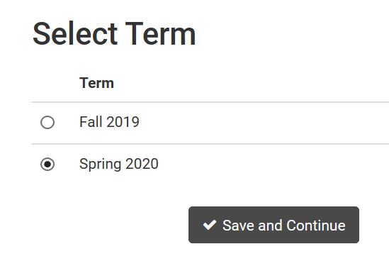
- Select the appropriate term. Click “Save and Continue”

- Ensure Undergraduate is selected. Click “Save and Continue”
- Verify the only campus selected is Oshkosh. Click “Save and Continue”

- Click “Add Course”

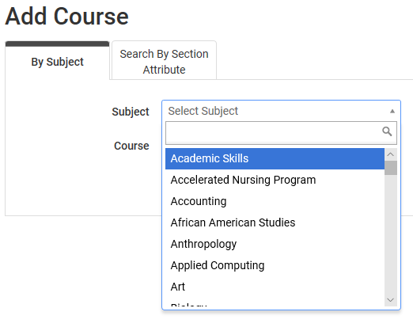
- Click the “Select Subject” drop down and select the subject of the course you would like to add
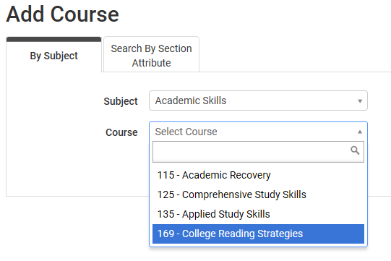
- Click the “Select Course” drop down
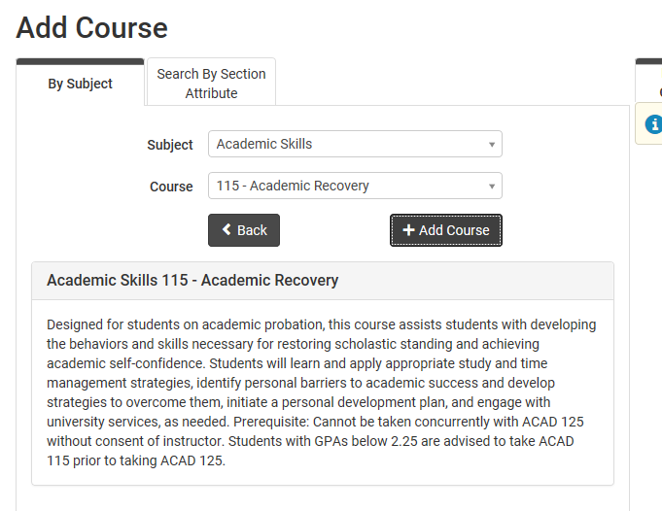
- You can click each course to view more details about the course.
- To add a course, click “Add Course”

- The course will then display under Desired Courses
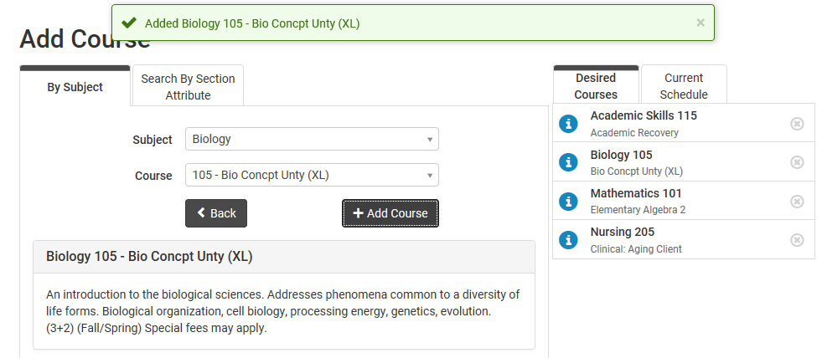
- Repeat steps 11-14 for all desired courses
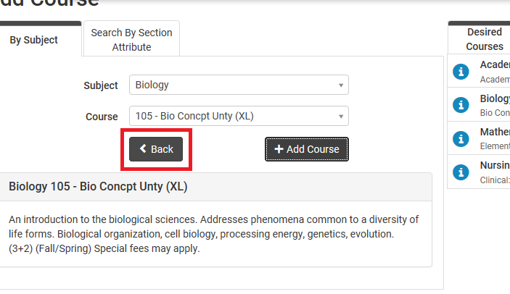
- When you’ve added your courses, click “Back”

- To generate schedules, click the “Generate Schedules” button under the Schedules section
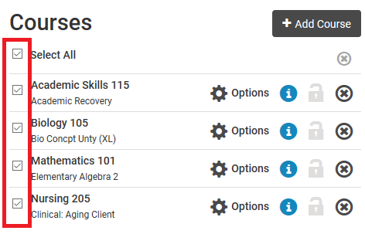
Tip: Any course selected under the Courses section will be used when generating schedules
- Hover your mouse over the magnifying glass for an overview of each weekly schedule

- To compare up to 4 schedules at a time, click the check box next to the schedules you’d like to compare.

- Click “Compare”

  - Hover your mouse over each color block to see which course is listed
  - Click “Open #__” to see the schedule in full view
- When you’ve selected which schedule you prefer, go to the full view of that schedule. Click “Send to Shopping Cart”
- Select “Register”

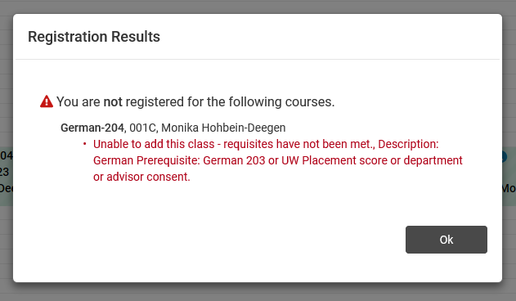
- Your registration results will appear:
Successful enrollment will display as:
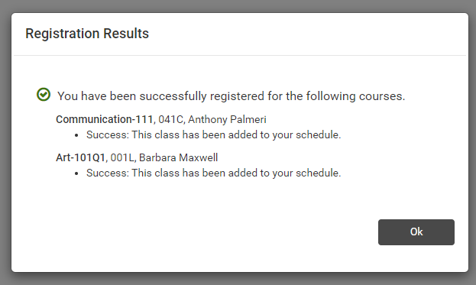
Enrollment errors will display as:
    - Unable to add this class –
department consent contact the course department (find number on UWO website in the directory)
requisites have not been met email your advisor a screenshot of the error message

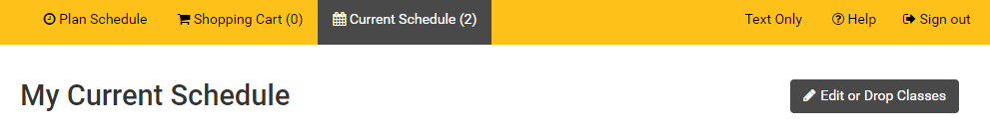
- Click “Ok” to see your Current Schedule. You can Drop Classes through College Scheduler as well (instructions for dropping courses in College Scheduler begin at step 27).
- To print a list of your final classes, you can close out of the College Scheduler tab and go back to Titan Web. From the Student Center, go to the drop down menu and select Class Schedule.
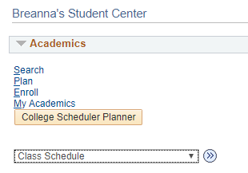Click arrows.
You may have to select the correct term
  - To print the list of courses, right click and select “print”
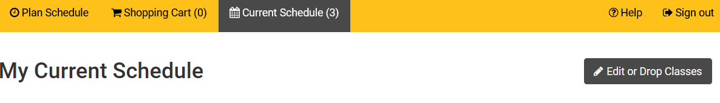
- Dropping courses via College Scheduler:
From the Current Schedule screen, click “Edit or Drop Classes”
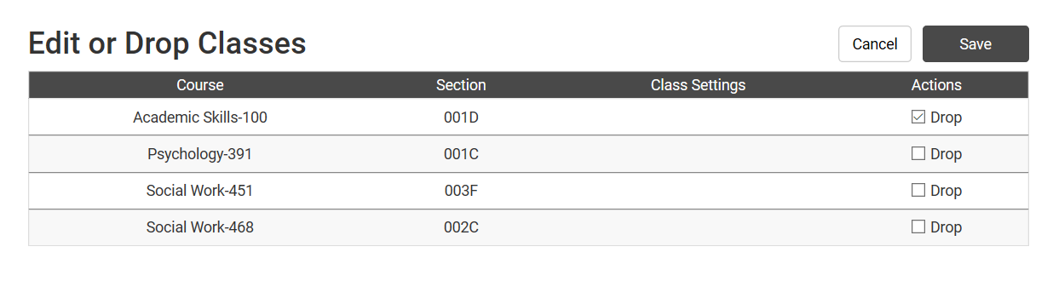
- Click the “Drop” check box for the course(s) you’d like to drop, click “Save”
- Click “Save” again. A green check indicates you’ve successfully dropped the course
