CITI Program Training for Animal Care and Use Program:

The newest version of the Guide for the Care and Use of Laboratory Animals stresses the importance of ongoing education for IACUC members and all animal users. Our Institution has purchased a subscription to the CITI Program to provide additional education beyond the Animal Care Certification course that we already offer. The training should be completed prior to submission of IACUC applications, but no later than immediately after the approval of applications AND always before beginning any work described in the approved protocol.

IACUC Chairs, members, alternates, and animal facility coordinators shall complete the following courses upon appointment and prior to conducting official business at a Full Committee meeting:
- Essentials for IACUC Members
- IACUC Chair (for IACUC chairperson or individuals planning to become a chairperson)
- IACUC Community Member (for non-affiliated IACUC members only)

Animal-using PIs and those students and/or staff listed on IACUC animal use applications shall complete the following courses:

Animal Care Facility Workers
- Working with the IACUC
- Post-Procedural Care: Reducing Pain and Distress
- Aseptic Surgery (For animal users planning to perform aseptic surgical procedures)

Field & Observational Researchers
- Working with the IACUC
- Wildlife Research

*If the new learner is both a PI and an IACUC member, learner will be required to take the Essential for IACUC Members, but will not have to take the Working with the IACUC module.

It is also recommended that as part of the species-specific training that the learner takes courses appropriate to the animal groups they plan to work with (Working with Fish, Working with Rats, Working with Hamsters, Working with Gerbils, Working with Amphibians, etc.)

Once a learner completes appropriate CITI courses, a completion report will be automatically e-mailed to IACUC Administration. The learner can print his/her completion report(s) from his 1 year). A refresher training course will be required once the original certificate expires.

Instructions for entering the CITI Program Training:
1. Go to www.citiprogram.org
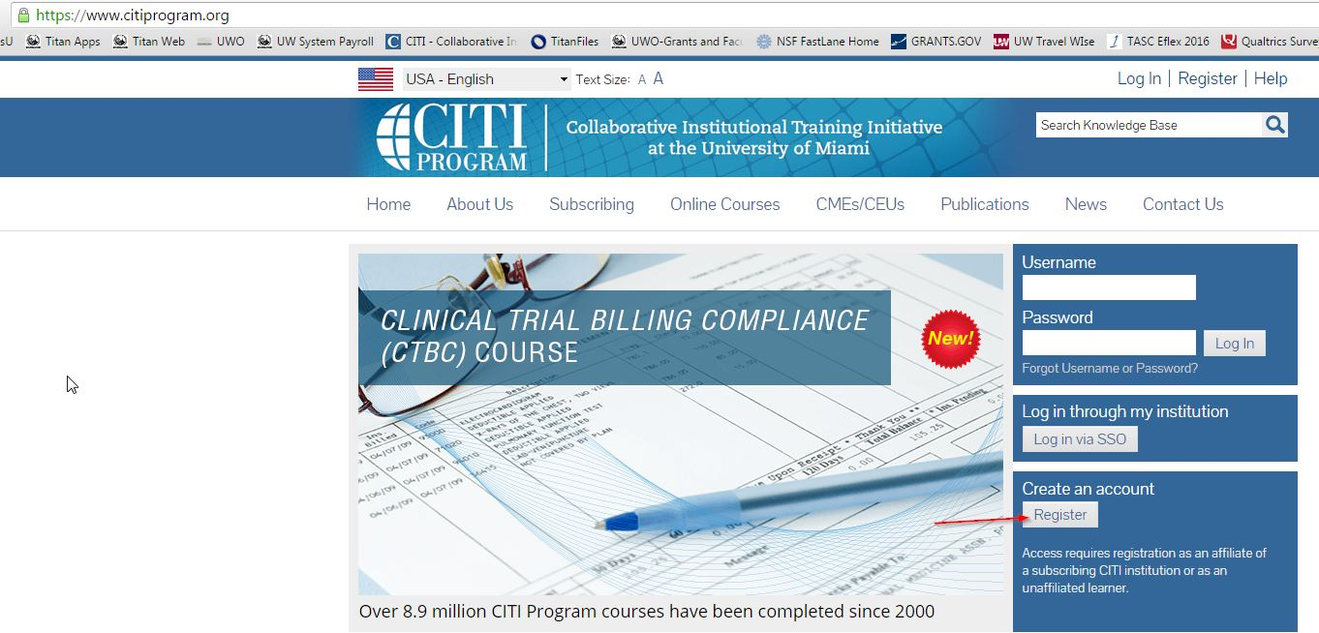
2. Select Register at the top. You will need to create your profile and affiliate with University of Wisconsin-Oshkosh.
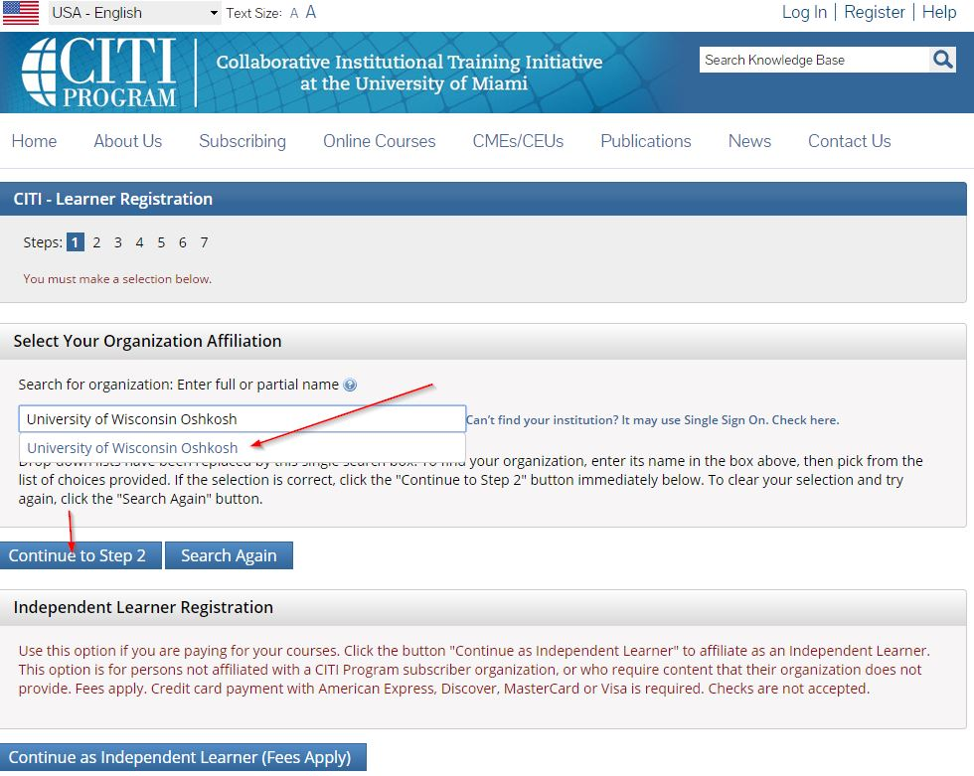
You will be asked a list of response-driven questions. Answer them according to your intended role in the animal care and use program. At the end of the questions, you will be assigned one or more courses in your Main Menu screen. You can click on each course link to enter the course. CITI training takes approximately 1-3 hours so please plan accordingly.
3. Once your Courses appear on your training page, you may enter the training. You may be required to complete the Integrity Assurance Statement (see below).There will be a quiz at the end of the modules and, when you pass the quiz, a notification will be sent to IACUC Administration.
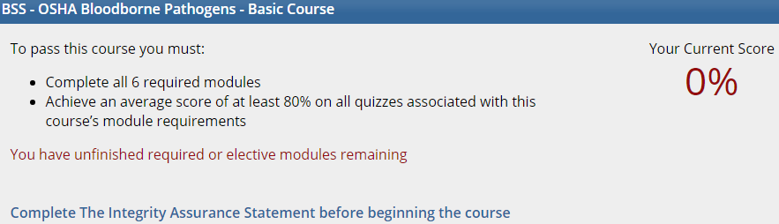

Training Clarification for UWO Animal Users
- Training of Research Personnel & Training Protocol
- When should research personnel be added to protocol?
- Upon Completion of Animal Certification & CITI Training. Prior to performing procedures on the protocol, the PI is responsible for ensuring that protocol specific training is provided and documented.
- When can research personnel begin performing procedures on the protocols in which they are listed?
- Once the PI, training coordinator, or expert designee has provided and documented training in protocol procedures in which they will be performing.
  - Training in aseptic surgical technique and protocol specific surgeries can be provided and documented by the PI, training coordinator, or expert designee.
For IP taps, surgeries, and retro-orbital eye bleeds, the veterinarian (or her designee) observes and documents when an individual is proficient and ready to perform the surgery or procedure on their own.
  - RARC surgery and rodent technique classes at UW-Madison are an additional resource that may be utilized for individuals new to surgery or procedures where expertise is needed. Training received at RARC is covered under the UW-Madison IACUC Training Protocol. Documentation regarding completion of RARC training should be provided to the training coordinator at UWO and kept in the individual’s training file.

- Training to Research Personnel in Protocol Specific Procedures by PI
- The PI can provide protocol specific training to research personnel (approved in the IACUC protocol) as they conduct procedures approved in the protocol.
- If the PI has a trained, experienced lab member that has demonstrated proficiency in all protocol procedures, that individual may provide training to lab members as well if they are approved by the training coordinator (Train the Trainer model).
- If the PI seeks expertise in a specific research procedure, the training coordinator or an expert designee may be provide training under Training Protocol # 313: Animals Utilized for Training Purposes.

- When would the use of the New Training Protocol be utilized?
- Training on live animals is provided by training coordinator or expert designee. This would allow individuals not listed on the research protocol to provide training in techniques and procedures. If an external expert will be providing training, the training coordinator must be notified in advance and grant approval. External experts would be exempted from the animal certification prerequisites, however a summary of experience/training will be requested and the completion of a Visitor Disclosure Form.
- PI and/or laboratory seeks training on a procedure that is not currently listed in any of their protocols or for a pilot study
- Animals for the training protocol may be sourced in the following manner: transferred from an existing research or breeding protocol, excess animals shipped from a vendor order, or ordered from a vendor (least desired in the spirit of the 3R’s)
- Animals sourced from existing protocols may be transferred to the training protocol via the Intra-Institutional Animal Transfer Form. A PI may choose to voluntarily transfer animals to the training protocol at their discretion for training purposes (i.e., consideration for procedures involving more than momentary pain or distress).
- Any animals used would be reported under the training protocol. The animal record should indicate all procedures performed on an animal. For USDA reporting purposes, the animal should be reported under the highest pain category it encountered during that reporting period.

